Quarterly Statistics by Banks, Employees and Branches

in Banking System

June 2024

Number of Banks

The number of deposit, development and investment banks was 63 at the end of June 2024 with 34 in deposit banks group and 20 in development and investment banks group, while there were also 9 participation banks.

Number of Banks in the System

* Banks under the Deposit Insurance Fund

Number of Employees

As of June 2024, the number of employees in deposit banks and development and investment banks was 189,592.

The number of employees decreased by 445 as compared to previous quarter and it increased by 764 to June 2023.

Compared to June 2023, the number of employees increased by 481 in deposit banks and it increased by 283 in development and investment banks.

Number of Employees (thousand people)

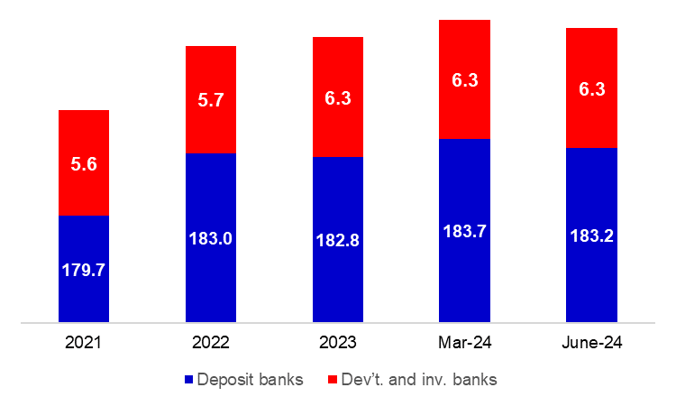

Bank Employees by Gender and Education Level

As of June 2024, 50.9 percent of the employees were female and 49.1 percent were male, regarding the distribution of bank employees by gender.

Regarding the education level of bank employees, 79 percent of the employees had undergraduate degrees and 10 percent in postgraduate degrees, as of June 2024. This share of high-school graduates was 11 percent.

Bank Employees by Gender and Education Level

43 percent of employees are in the 36-45 age range, and 38 percent are in the 26-35 age range.

Bank Employees by Age (percent)

Number of Branches

As of June 2024, the total number of branches in deposit banks and development and investment banks was 9,461.

Number of Branches*
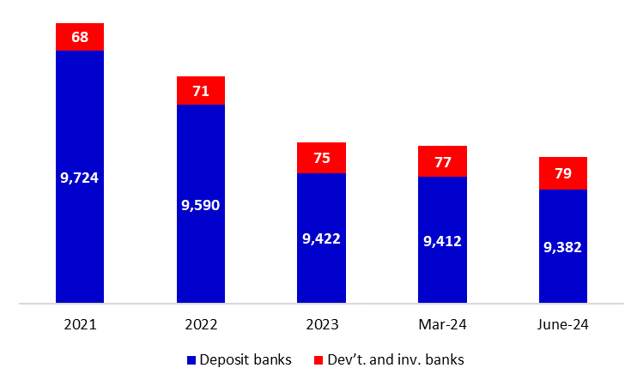

* Branches in foreign countries and Turkish Republic of Northern Cyprus are included.

The number of branches decreased by 28, as compared to previous quarter and by 177, as compared to June 2023.

Branches and Employees per 100,000 people

As of June 2024, employees per 100,000 people was 222 and branches per 100,000 people was 11.1.

Branches and Employees per 100,000 people*

* June 2024 population data were used in the 2023 calculations.

-The deposit banks and development and investment banks are included for the figures of employees and branches.

