Quarterly Statistics by Banks, Employees and Branches

in Banking System

March 2024

Number of Banks

The number of deposit, development and investment banks was 63 at the end of March 2024 with 34 in deposit banks group and 20 in development and investment banks group, while there were also 9 participation banks. With the decision of the Banking Regulation and Supervision Agency, "Hedef Yatırım Bankası A.Ş" was licenced to operate.

Number of Banks in the System

* Banks under the Deposit Insurance Fund

Number of Employees

As of March 2024, the number of employees in deposit banks and development and investment banks was 190,037.

Number of Employees

 | March 2023 | December 2023 | March 2024
Deposit banks | 185,581 | 182,790 | 183,735
Dev’t. and inv. banks | 5,604 | 6,317 | 6,302
Total | 191,185 | 189,107 | 190,037

The number of employees increased by 930 as compared to previous quarter and it decreased by 1,148 to March 2023.

Compared to March 2023, the number of employees decreased by 1,846 in deposit banks and it increased by 698 in development and investment banks.

Number of Employees (Number of people)
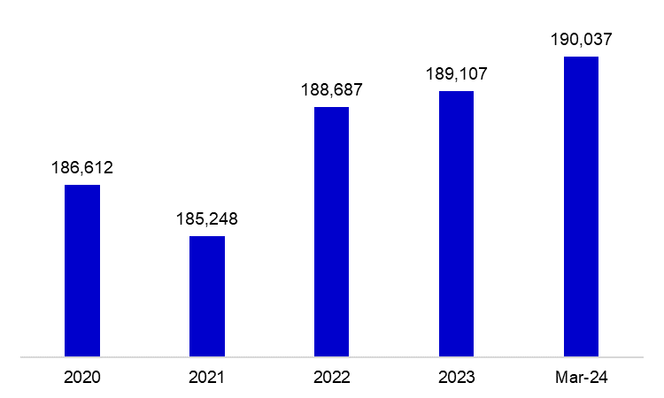

Bank Employees by Gender and Education Level

As of March 2024, 50.8 percent of the employees were female and 49.2 percent were male, regarding the distribution of bank employees by gender.

Regarding the education level of bank employees, 79 percent of the employees had undergraduate degrees and 9 percent in postgraduate degrees, as of March 2024. This share of high-school graduates was 11 percent.

Bank Employees by Gender and Education Level

The age distribution of employees in the banking sector has been compiled and published by the Banks Association of Turkey since December 2022. Accordingly, 43 percent of employees are in the 36-45 age range, and 38 percent are in the 26-35 age range.

Bank Employees by Age (percent)

Number of Branches

As of March 2024, the total number of branches in deposit banks and development and investment banks was 9,496.

Number of Branches*

 | March 2023 | December 2023 | March 2024
Deposit banks | 9,595 | 9,422 | 9,419
Dev’t, and inv, banks | 71 | 75 | 77
Total | 9,666 | 9,497 | 9,496
* Branches in foreign countries and Turkish Republic of Northern Cyprus are included.

The number of branches decreased by 1, as compared to previous quarter and by 170, as compared to March 2023.

The number of branches per bank was 277 in deposit banks at the end of March 2024.

Number of Branches
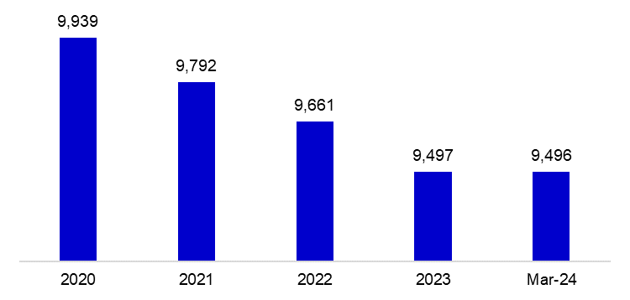

The rapid growth of non-branch channels and delegation of some services to outsourcing institutions affected the number of employees and branches.

Branches and Employees per 100,000 people

As of March 2024, employees per 100,000 people was 223 and branches per 100,000 people was 11.1.

Branches and Employees per 100,000 people*

* March 2024 population data were used in the 2023 calculations.

-The deposit banks and development and investment banks are included for the figures of employees and branches.

