Quarterly Statistics by Banks, Employees and Branches

in Banking System[1]

March 2023

Number of Banks

The number of deposit, development and investment banks was 58 at the end of March 2023 with 35 in deposit banks group and 17 in development and investment banks group, while there were also 6 participation banks.

Number of Banks in the System

*\* Banks under the Deposit Insurance Fund*

Number of Employees

As of March 2023, the number of employees in deposit banks and development and investment banks was 191,209.

Number of Employees

|  |  |  |  |
| --- | --- | --- | --- |
|  | **March 2022** | **December 2022** | **March 2023** |
| Deposit banks | 179,401 | 182,987 | 185,605 |
| Dev’t. and inv. banks | 5,599 | 5,700 | 5,604 |
| **Total** | **185,000** | **188,687** | **191,209** |

The number of employees increased by 2,522 as compared to previous quarter and by 6,209 as compared to March 2022.

The number of employees increased by 6,204 in deposit banks and by 5 in development and investment banks.

Number of Employees (thousand people)

Bank Employees by Gender and Education Level

As of March 2023, 50.8 percent of the employees were female and 49.2 percent were male, regarding the distribution of bank employees by gender.

Regarding the education level of bank employees, 79 percent of the employees had undergraduate degrees and 9 percent in postgraduate degrees, as of March 2023. This share of high-school graduates was 11 percent.

Bank Employees by Gender and Education Level

The age distribution of employees in the banking sector has been compiled and published by the Banks Association of Turkey since December 2022. Accordingly, 42 percent of employees are in the 36-45 age range, and 38 percent are in the 26-35 age range.

**Bank Employees by Age (percent)**

Number of Branches

As of March 2023, the total number of branches in deposit banks and development and investment banks was 9,667.

**Number of Branches\***

|  |  |  |  |
| --- | --- | --- | --- |
|  | **March 2022** | **December 2022** | **March 2023** |
| Deposit banks | 9,715 | 9,590 | 9,596 |
| Dev’t. and inv. banks | 71 | 71 | 71 |
| **Total** | **9,786** | **9,661** | **9,667** |

*\* Branches in foreign countries and Turkish Republic of Northern Cyprus are included.*

The number of branches decreased by 119, as compared to previous quarter and increased by 6, as compared to March 2023.

The number of branches per bank was 274 in deposit banks at the end of March 2023.

**Number of Branches**

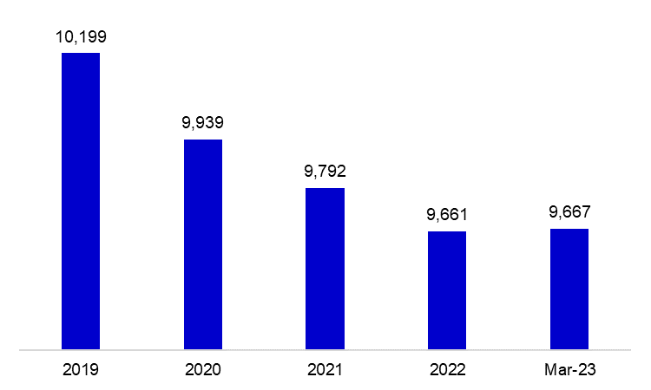

The rapid growth of non-branch channels and delegation of some services to outsourcing institutions affected the number of employees and branches.

**Branches and Employees per 100,000 people**

As of March 2023, employees per 100,000 people was 224 and branches per 100,000 people was 11.3.

**Branches and Employees per 100,000 people**\*

* 2022 population data were used in the 2023 calculations.

1. -The deposit banks and development and investment banks are included for the figures of employees and branches.