Quarterly Statistics by Banks, Employees and Branches

in Banking System[1]

December 2022

Number of Banks

The number of deposit, development and investment banks was 58 at the end of December 2022 with 35 in deposit banks group and 17 in development and investment banks group, while there were also 6 participation banks. Operating licenses have been granted to İnveo Yatırım Bankası A.Ş. at December 2022. On December 26, 2022, its name was changed to Misyon Yatırım Bankası A.Ş.

Number of Banks in the System

*\* Banks under the Deposit Insurance Fund*

Number of Employees

As of December 2022, the number of employees in deposit banks and development and investment banks was 188,660.

Number of Employees

|  |  |  |  |
| --- | --- | --- | --- |
|  | **December 2021** | **September 2022** | **December 2022** |
| Deposit banks | 179,681 | 181,953 | 182,987 |
| Dev’t. and inv. banks | 5,567 | 5,633 | 5,700 |
| **Total** | **185,248** | **187,586** | **188,687** |

The number of employees increased by 1,101 as compared to previous quarter and by 3,439 as compared to December 2021.

The number of employees increased by 3,306 in deposit banks and by 133 in development and investment banks.

Number of Employees (thousand people)

Bank Employees by Gender and Education Level

As of December 2022, 50.5 percent of the employees were female and 49.5 percent were male, regarding the distribution of bank employees by gender.

Regarding the education level of bank employees, 78 percent of the employees had undergraduate degrees and 9 percent in postgraduate degrees, as of December 2022. This figure was 12 percent in high-school graduates.

Bank Employees by Gender and Education Level

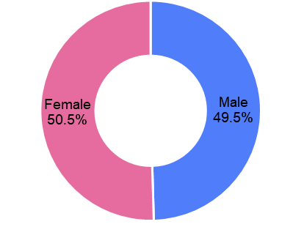

The age distribution of employees in the banking sector has been compiled and published by the Banks Association of Turkey since December 2022. Accordingly, 42 percent of employees are in the 36-45 age range, and 38 percent are in the 26-35 age range.

**Bank Employees by Age (percent)**

Number of Branches

As of December 2022, the total number of branches in deposit banks and development and investment banks was 9,661.

**Number of Branches\***

|  |  |  |  |
| --- | --- | --- | --- |
|  | **December 2021** | **September 2022** | **December 2022** |
| Deposit banks | 9,724 | 9,641 | 9,590 |
| Dev’t. and inv. banks | 68 | 71 | 71 |
| **Total** | **9,792** | **9,712** | **9,661** |

*\* Branches in foreign countries and Turkish Republic of Northern Cyprus are included.*

The number of branches decreased by 51, as compared to previous quarter and by 131, as compared to December 2021.

The number of branches per bank was 274 in deposit banks at the end of December 2022.

**Number of Branches**

The rapid growth of non-branch channels and delegation of some services to outsourcing institutions affected the number of employees and branches.

**Branches and Employees per 100,000 people**

As of December 2022, employees per 100,000 people was 223 and branches per 100,000 people was 11.4.

**Branches and Employees per 100,000 people**\*

* 2021 population data were used in the 2022 calculations.

1. -The deposit banks and development and investment banks are included for the figures of employees and branches.

   -Number of employees figure of December 2022 was updated by a bank, as of March 7, 2023.