Quarterly Statistics by Banks, Employees and Branches

in Banking System[1]

September 2022

Number of Banks

The number of deposit, development and investment banks was 57 at the end of September 2022 with 35 in deposit banks group and 16 in development and investment banks group, while there were also 6 participation banks. Operating licenses have been granted to Destek Yatırım Bankası at February 2022 and to Türk Ticaret Bankası at April 2022.

Number of Banks in the System

*\* Banks under the Deposit Insurance Fund*

Number of Employees

As of September 2022, the number of employees in deposit banks and development and investment banks was 187,586.

Number of Employees

|  |  |  |  |
| --- | --- | --- | --- |
|  | **September 2021** | **December 2021** | **September 2022** |
| Deposit banks | 179,281 | 179,681 | 181,953 |
| Dev’t. and inv. banks | 5,413 | 5,567 | 5,633 |
| **Total** | **184,694** | **185,248** | **187,586** |

The number of employees increased by 1,930 as compared to previous quarter and by 2,892 as compared to September 2021.

The number of employees increased by 2,672 in deposit banks and by 220 in development and investment banks.

Number of Employees (thousand people)

Bank Employees by Gender and Education Level

As of September 2022, 50.5 percent of the employees were female and 49.5 percent were male, regarding the distribution of bank employees by gender.

Regarding the education level of bank employees, 78 percent of the employees had undergraduate degrees and 9 percent in postgraduate degrees, as of September 2022. This figure was 12 percent in high-school graduates.

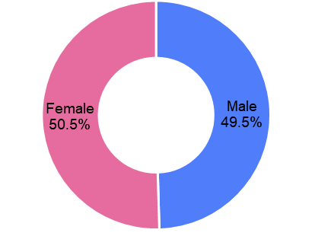Bank Employees by Gender and Education Level

The age distribution of employees in the banking sector has been compiled and published by the Banks Association of Turkey since June 2022. Accordingly, 42 percent of employees are in the 36-45 age range, and 39 percent are in the 26-35 age range.

**Bank Employees by Age (percent)**

Number of Branches

As of September 2022, the total number of branches in deposit banks and development and investment banks was 9,712.

**Number of Branches\***

|  |  |  |  |
| --- | --- | --- | --- |
|  | **September 2021** | **December 2021** | **September 2022** |
| Deposit banks | 9,795 | 9,724 | 9,641 |
| Dev’t. and inv. banks | 68 | 68 | 71 |
| **Total** | **9,863** | **9,792** | **9,712** |

*\* Branches in foreign countries and Turkish Republic of Northern Cyprus are included.*

The number of branches decreased by 41, as compared to previous quarter and by 80, as compared to September 2021.

The number of branches per bank was 275 in deposit banks at the end of September 2022.

**Number of Branches**

The rapid growth of non-branch channels and delegation of some services to outsourcing institutions affected the number of employees and branches.

**Branches and Employees per 100,000 people**

As of September 2022, employees per 100,000 people was 221 and branches per 100,000 people was 11.4.

**Branches and Employees per 100,000 people**\*

* 2021 population data were used in the 2022 calculations.

1. -The deposit banks and development and investment banks are included for the figures of employees and branches.