Quarterly Statistics by Banks, Employees and Branches

in Banking System[1]

March 2022

Number of Banks

The number of deposit, development and investment banks was 57 at the end of March 2022 with 35 in deposit banks group and 16 in development and investment banks group, while there were also 6 participation banks. Operating licenses have been granted to Destek Yatırım Bankası A.Ş. at January 2022

**Number of Banks in the System**

*\* Banks under the Deposit Insurance Fund*

Number of Employees

As of March 2022, the number of employees in deposit banks and development and investment banks was 185,000

Number of Employees

|  |  |  |  |
| --- | --- | --- | --- |
|  | **March 2021** | **December 2021** | **March 2022** |
| Deposit banks | 180,889 | 179,681 | 179,401 |
| Dev’t. and inv. banks | 5,092 | 5,567 | 5,599 |
| **Total** | **185,981** | **185,248** | **185,000** |

The number of employees decreased by 248 as compared to previous quarter and decreased by 981 as compared to March 2021.

The number of employees decreased by 1,488 in deposit banks and increased by 507 in development and investment banks.

Number of Employees

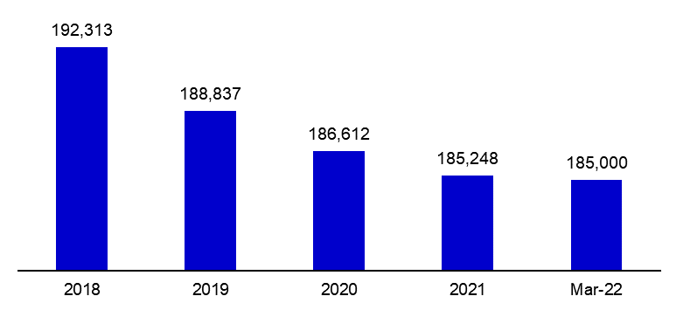

Bank Employees by Gender and Education Level

As of March 2022 50,5 percent of the employees were female regarding the distribution of bank employees by gender.

Regarding the education level of bank employees, 78 percent of the employees had undergraduate degrees and 8 percent in postgraduate degrees, as of March 2022. This figure was 13 percent in high-school graduates.

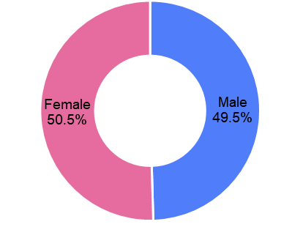Bank Employees by Gender and Education Level

Number of Branches

As of March 2022, the total number of branches in deposit banks and development and investment banks was 9,786.

**Number of Branches\***

|  |  |  |  |
| --- | --- | --- | --- |
|  | **March 2021** | **December 2021** | **March 2022** |
| Deposit banks | 9,858 | 9,724 | 9,715 |
| Dev’t. and inv. banks | 66 | 68 | 71 |
| **Total** | **9,924** | **9,792** | **9,786** |

*\* Branches in foreign countries and Turkish Republic of Northern Cyprus are included.*

The number of branches decreased by 6, as compared to previous quarter and by 138, as compared to March 2021.

The number of branches per bank was 278 in deposit banks at the end of March 2022.

**Number of Branches**

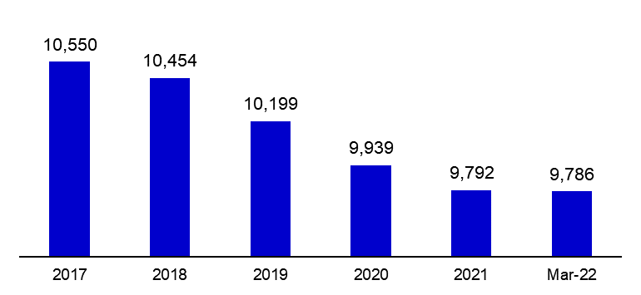

The rapid growth of non-branch channels and delegation of some services to outsourcing institutions affected the number of employees and branches.

**Branches and Employees per 100,000 people**

As of March 2022, employees per 100,000 people was 220 and branches per 100,000 people was 11.6.

**Branches and Employees per 100,000 people**\*

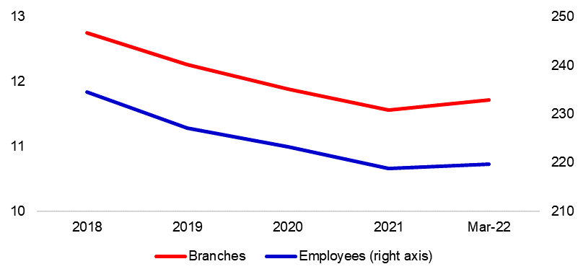

*: 2021 population data were used in the calculations.

1. -The deposit banks and development and investment banks are included for the figures of employees and branches.