Quarterly Statistics by Banks, Employees and Branches

in Banking System[1]

December 2021

Number of Banks

The number of deposit, development and investment banks was 57 at the end of December 2021 with 34 in deposit banks group and 15 in development and investment banks group, while there were also 6 participation banks. Operating licenses have been granted to "Türk Ticaret Bankası A.Ş." and to Destek Yatırım Bankası A.Ş. These banks have not yet started operating.

**Number of Banks in the System**

*\* Banks under the Deposit Insurance Fund*

Number of Employees

As of 2021, the number of employees in deposit banks and development and investment banks was 185,248

Number of Employees

|  |  |  |  |
| --- | --- | --- | --- |
|  | **December 2020** | **September 2021** | **December 2021** |
| Deposit banks | 181,488 | 179,281 | 179,681 |
| Dev’t. and inv. banks | 5,124 | 5,413 | 5,567 |
| **Total** | **186,612** | **184,694** | **185,248** |

The number of employees increased by 554 as compared to previous quarter and decreased by 1,364 (0.7 percent), as compared to 2020.

The number of employees decreased by 1,807 in deposit banks and increased by 443 in development and investment banks.

Number of Employees

Bank Employees by Gender and Education Level

As of 2021 50,4 percent of the employees were female regarding the distribution of bank employees by gender.

Regarding the education level of bank employees, 78 percent of the employees had undergraduate degrees and 8 percent in postgraduate degrees, as of 2021. This figure was 13 percent in high-school graduates.

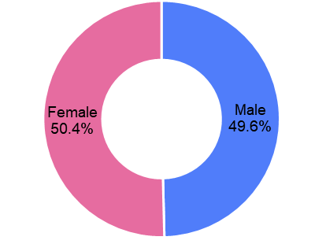Bank Employees by Gender and Education Level

Number of Branches

As of 2021, the total number of branches in deposit banks and development and investment banks was 9,792.

**Number of Branches\***

|  |  |  |  |
| --- | --- | --- | --- |
|  | **December 2020** | **September 2021** | **December 2021** |
| Deposit banks | 9,875 | 9,795 | 9,724 |
| Dev’t. and inv. banks | 64 | 68 | 68 |
| **Total** | **9,939** | **9,863** | **9,792** |

*\* Branches in foreign countries and Turkish Republic of Northern Cyprus are included.*

The number of branches decreased by 136, as compared to previous quarter and by 256, as compared to 2020.

The number of branches per bank was 278 in deposit banks at the end of 2021

**Number of Branches**

The rapid growth of non-branch channels and delegation of some services to outsourcing institutions affected the number of employees and branches.

**Branches and Employees per 100,000 people**

As of 2021, employees per 100,000 people was 222 and branches per 100,000 people was 11.7.

**Branches and Employees per 100,000 people**\*

*: 2020 population data were used in the calculations.

1. -The deposit banks and development and investment banks are included for the figures of employees and branches.