Quarterly Statistics by Banks, Employees and Branches

in Banking System[1]

June 2021

Number of Banks

The number of deposit, development and investment banks was 55 at the end of June 2021 with 34 in deposit banks group and 15 in development and investment banks group, while there were also 6 participation banks.

**Number of Banks in the System**

*\* Banks under the Deposit Insurance Fund*

Number of Employees

As of June 2021, the number of employees in deposit banks and development and investment banks was 185.115.

Number of Employees

|  |  |  |  |
| --- | --- | --- | --- |
|  | **June 2020** | **December 2020** | **June 2021** |
| Deposit banks | 182,331 | 181,489 | 180,019 |
| Dev’t. and inv. banks | 5,159 | 5,124 | 5,096 |
| **Total** | **187,490** | **186,613** | **185,115** |

The number of employees decreased by 1,498 as compared to December 2020 and by 2,312 (1.3 percent), as compared to June 2020.

**Number of Employees**

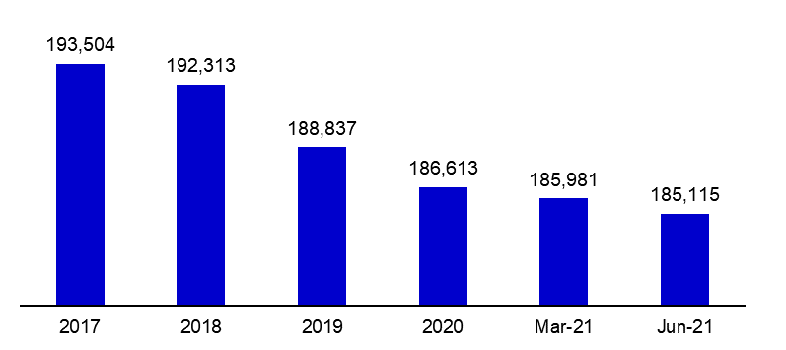

Bank Employees by Gender and Education Level

As of June 2021 50,5 percent of the employees were female regarding the distribution of bank employees by gender.

Regarding the education level of bank employees, 78 percent of the employees had undergraduate degrees and 8 percent in postgraduate degrees, as of March 2021. This figure was 13 percent in high-school graduates.

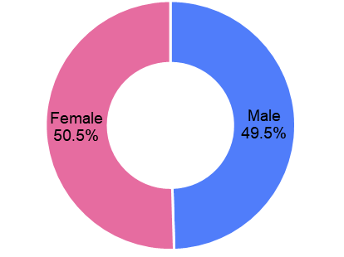Bank Employees by Gender and Education Level

Number of Branches

As of June 2021, the total number of branches in deposit banks and development and investment banks was 9,893.

**Number of Branches\***

|  |  |  |  |
| --- | --- | --- | --- |
|  | **March 2020** | **December 2020** | **March 2021** |
| Deposit banks | 10,071 | 9,879 | 9,827 |
| Dev’t. and inv. banks | 61 | 64 | 66 |
| **Total** | **10,132** | **9,943** | **9,893** |

*\* Branches in foreign countries and Turkish Republic of Northern Cyprus are included.*

The number of branches decreased by 50, as compared to December 2020 and by 239, as compared to June 2020.

The number of branches per bank was 289 in deposit banks at the end of June 2021.

Number of Branches

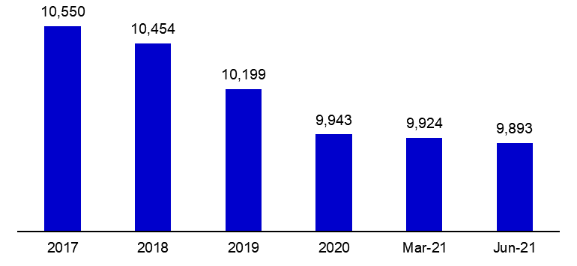

The rapid growth of non-branch channels and delegation of some services to outsourcing institutions affected the number of employees and branches.

**Branches and Employees per 100,000 people**

As of June 2021, employees per 100,000 people was 221 and branches per 100,000 people was 12.

**Branches and Employees per 100,000 people**\*

*: 2020 population data were used in the calculations.

1. The deposit banks and development and investment banks are included for the figures of employees and branches.