Quarterly Statistics by Banks, Employees and Branches

in Banking System[1]

March 2021

Number of Banks

The number of deposit, development and investment banks was 54 at the end of March 2021 with 34 in deposit banks group and 14 in development and investment banks group, while there were also 6 participation banks.

**Number of Banks in the System**

*\* Banks under the Deposit Insurance Fund*

Number of Employees

As of March 2021, the number of employees in deposit banks and development and investment banks was 185.981.

Number of Employees

|  |  |  |  |
| --- | --- | --- | --- |
|  | **March 2020** | **December 2020** | **March 2021** |
| Deposit banks | 182,994 | 181,489 | 180,889 |
| Dev’t. and inv. banks | 5,170 | 5,124 | 5,092 |
| **Total** | **188,164** | **186,613** | **185,981** |

The number of employees decreased by 632 as compared to previous quarter and by 2,183 (1.2 percent), as compared to March 2020.

**Number of Employees**

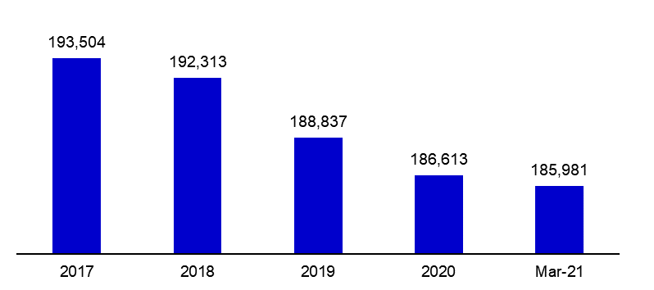

Bank Employees by Gender and Education Level

As of March 2021 50,4 percent of the employees were female regarding the distribution of bank employees by gender.

Regarding the education level of bank employees, 78 percent of the employees had undergraduate degrees and 8 percent in postgraduate degrees, as of March 2021. This figure was 13 percent in high-school graduates.

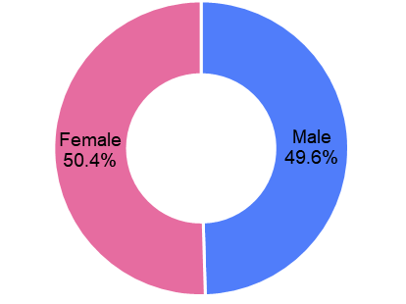Bank Employees by Gender and Education Level

Number of Branches

As of March 2021, the total number of branches in deposit banks and development and investment banks was 9,924.

**Number of Branches\***

|  |  |  |  |
| --- | --- | --- | --- |
|  | **March 2020** | **December 2020** | **March 2021** |
| Deposit banks | 10,099 | 9,879 | 9,858 |
| Dev’t. and inv. banks | 62 | 64 | 66 |
| **Total** | **10,161** | **9,943** | **9,924** |

*\* Branches in foreign countries and Turkish Republic of Northern Cyprus are included.*

The number of branches decreased by 19, as compared to previous quarter and by 237, as compared to March 2020.

The number of branches per bank was 290 in deposit banks at the end of March 2021.

Number of Branches

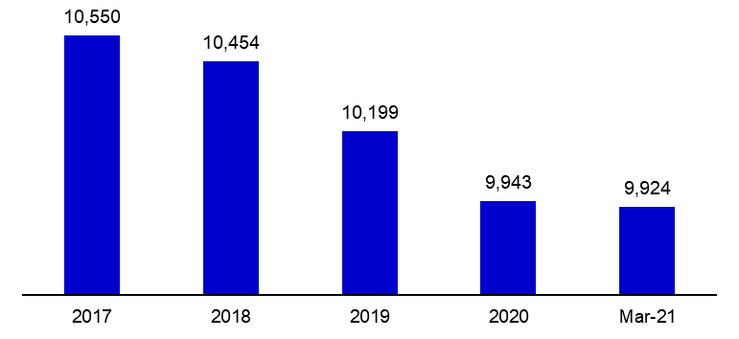

The rapid growth of non-branch channels and delegation of some services to outsourcing institutions affected the number of employees and branches.

**Branches and Employees per 100,000 people**

As of March 2021, employees per 100,000 people was 224 and branches per 100,000 people was 12.

**Branches and Employees per 100,000 people**\*

*: 2020 population data were used in the calculations.

1. -The deposit banks and development and investment banks are included for the figures of employees and branches.