Quarterly Statistics by Banks, Employees and Branches

in Banking System[1]

June 2020

Number of Banks

The number of deposit, development and investment banks was 54 at the end of March 2020 with 34 in deposit banks group and 13 in non-deposit banks group, while there were also 6 participation banks. “Golden Global Yatırım Bankası A.Ş.” was granted with an operation license with the BRSA resolution dated January 30, 2020 has started operations as of June 2020.

**Number of Banks in the System**

*\* Banks under the Deposit Insurance Fund*

Number of Employees

As of June 2020, the number of employees in deposit banks and development and investment banks was 187,490.

Number of Employees

|  |  |  |  |
| --- | --- | --- | --- |
|  | **June 2019** | **December 2019** | **June 2020** |
| Deposit banks | 185,184 | 183,659 | 182,331 |
| Dev’t. and inv. banks | 5,309 | 5,178 | 5,159 |
| **Total** | **190,493** | **188,837** | **187,490** |

The number of employees decreased by 674 as compared to previous quarter and by 3,003 (1.6 percent), as compared to June 2019.

**Number of Employees**

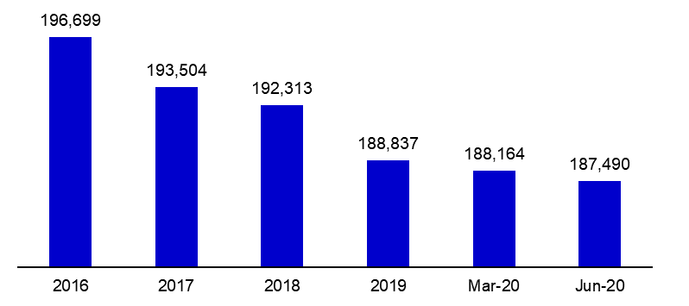

Bank Employees by Gender and Education Level

As of June 2020 51 percent of the employees were female regarding the distribution of bank employees by gender.

Regarding the education level of bank employees, 78 percent of the employees had undergraduate degrees and 8 percent in postgraduate degrees, as of March 2020. This figure was 13 percent in high-school graduates.

Bank Employees by Gender and Education Level

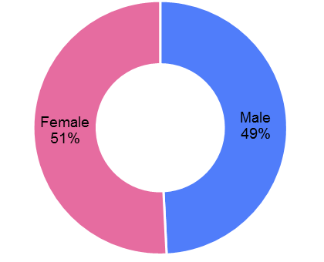

Number of Branches

As of June 2020, the total number of branches in deposit banks and development and investment banks was 10,132.

**Number of Branches\***

|  |  |  |  |
| --- | --- | --- | --- |
|  | **June 2019** | **December 2019** | **June 2020** |
| Deposit banks | 10,302 | 10,137 | 10,071 |
| Dev’t. and inv. banks | 57 | 62 | 61 |
| **Total** | **10,359** | **10,199** | **10,132** |

*\* Branches in foreign countries and Turkish Republic of Northern Cyprus are included.*

The number of branches decreased by 29, as compared to previous quarter and by 227, as compared to June 2019.

The number of branches per bank was 296 in deposit banks at the end of the June 2020.

Number of Branches

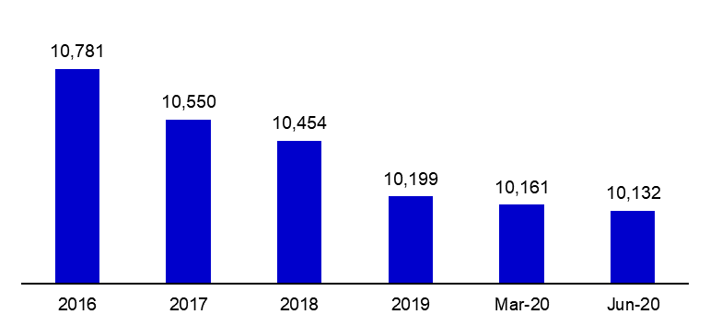

The rapid growth of non-branch channels and delegation of some services to outsourcing institutions affected the number of employees and branches.

**Branches and Employees per 100,000 people**

As of June 2020, employees per 100,000 people decreased 2 points to 225 as compared to end of the 2019.

**Branches and Employees per 100,000 people**\*

*: 2019 population data were used in the calculations.

1. -The deposit banks and development and investment banks are included.