Quarterly Statistics by Banks, Employees and Branches

in Banking System[1]

September 2019

Number of Banks

The number of deposit, development and investment banks was 53 at the end of September 2019 with 34 in deposit banks group and 13 in non-deposit banks group, while there were also 6 participation banks.

**Number of Banks in the System**

*\* Banks under the Deposit Insurance Fund*

Number of Employees

As of September 2019, the number of employees in deposit banks and development and investment banks was 189,507.

Number of Employees

|  |  |  |  |
| --- | --- | --- | --- |
|  | **September 2018** | **December 2018** | **September 2019** |
| Deposit banks | 187,919 | 186,918 | 184,324 |
| Dev’t. and inv. banks | 5,424 | 5,395 | 5,183 |
| **Total** | **193,343** | **192,313** | **189,507** |

The number of employees decreased by 3,836 (2 percent), as compared to September 2018 and by 2,806 as compared to end of the 2018.

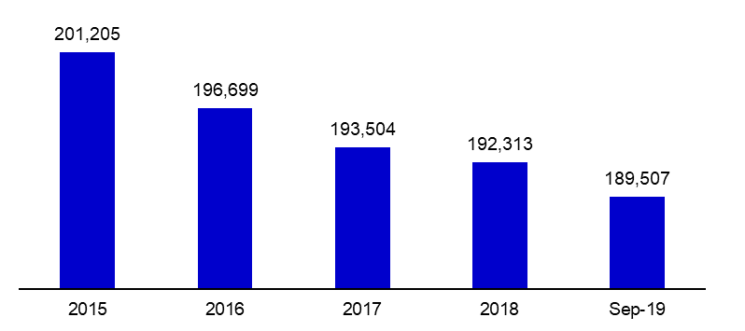**Number of Employees**

Bank Employees by Gender and Education Level

As of September 2019, 51 percent of the employees were female regarding the distribution of bank employees by gender.

Regarding the education level of bank employees, 78 percent of the employees had undergraduate degrees and 8 percent in postgraduate degrees, as of September 2019. This figure was 13 percent in high-school graduates.

Bank Employees by Gender and Education Level

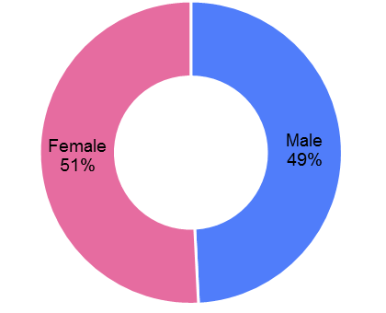

Number of Branches

As of September 2019, the total number of branches in deposit banks and development and investment banks was 10,289.

**Number of Branches\***

|  |  |  |  |
| --- | --- | --- | --- |
|  | **September 2018** | **December 2018** | **September 2019** |
| Deposit banks | 10,452 | 10,400 | 10,231 |
| Dev’t. and inv. banks | 53 | 54 | 58 |
| **Total** | **10,505** | **10,454** | **10,289** |

*\* Branches in foreign countries and Turkish Republic of Northern Cyprus are included.*

This number decreased by 216, as compared to September 2018 and by 165, as compared to December 2018.

The number of branches per bank was 301 in deposit banks at the end of September 2019.

Number of Branches

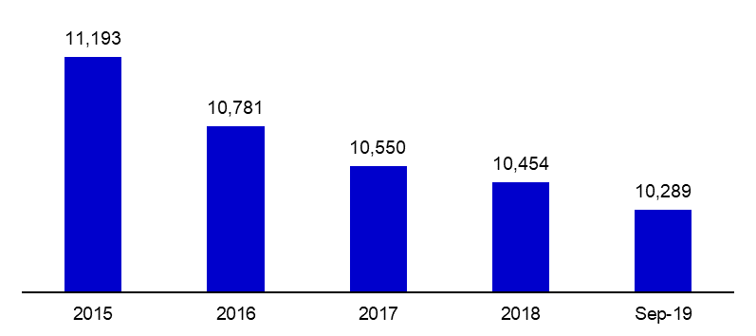

The rapid growth of non-branch channels and delegation of some services to outsourcing institutions affected the number of employees and branches.

**Branches and Employees per 100,000 people**

As of September 2019, employees per 100,000 people decreased 4 point to 231 as compared to end of the 2018.

**Branches and Employees per 100,000 people**

*: 2018 population data were used in the calculations.

As of September 2019, employees per 100,000 people decreased 0.2 point to 12.5 as compared to end of the 2018.

1. -The deposit banks and development and investment banks are included.