Quarterly Statistics by Banks, Employees and Branches

in Banking System[1]

March 2019

Number of Banks

The number of deposit, development and investment banks was 53 at the end of March 2019 with 34 in deposit banks group and 13 in non-deposit banks group, while there were also 6 participation banks. Emlak Participation Bank A.Ş. has taken permission to make banking operations on the 26th of February, 2019 and started its operations on the 21st of March, 2019.

**Number of Banks in the System**

*\* Banks under the Deposit Insurance Fund*

Number of Employees

As of March 2019, the number of employees in deposit banks and development and investment banks was 190,908.

Number of Employees

|  |  |  |  |
| --- | --- | --- | --- |
|  | **March 2018** | **December 2018** | **March 2019** |
| Deposit banks | 187,920 | 186,918 | 185,581 |
| Dev’t. and inv. banks | 5,257 | 5,395 | 5,327 |
| **Total** | **193,177** | **192,313** | **190,908** |

The number of employees decreased by 2,269 (1.2 percent), as compared to March 2018 and by 1,405 as compared to end of the 2018.

**Number of Employees**

Bank Employees by Gender and Education Level

As of March 2019, 51 percent of the employees were female regarding the distribution of bank employees by gender.

Regarding the education level of bank employees, 78 percent of the employees had undergraduate degrees and 8 percent in postgraduate degrees, as of March 2019. This figure was 13 percent in high-school graduates.

Bank Employees by Gender and Education Level

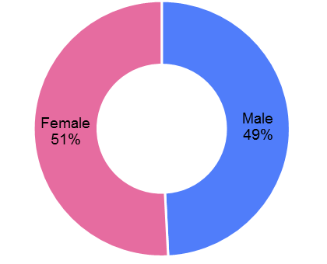

Number of Branches

As of March 2019, the total number of branches in deposit banks and development and investment banks was 10,412.

**Number of Branches\***

|  |  |  |  |
| --- | --- | --- | --- |
|  | **March 2018** | **December 2018** | **March 2019** |
| Deposit banks | 10,460 | 10,400 | 10,355 |
| Dev’t. and inv. banks | 50 | 54 | 57 |
| **Total** | **10,510** | **10,454** | **10,412** |

*\* Branches in foreign countries and Turkish Republic of Northern Cyprus are included.*

This number decreased by 98, as compared to March 2018 and by 42, as compared to December 2018.

The number of branches per bank was 305 in deposit banks at the end of March 2019.

Number of Branches

The rapid growth of non-branch channels and delegation of some services to outsourcing institutions affected the number of employees and branches.

**Employees per branch**

The average number of employees per branch was 18. This number was 18 in deposit banks and 93 in development and investment banks as of March 2019.

Employees per branch

1. -The deposit banks and development and investment banks are included.