Quarterly Statistics by Banks, Employees and Branches

in Banking System[1]

December 2018

Number of Banks

The number of deposit, development and investment banks was 52 at the end of December 2018 with 34 in deposit banks group and 13 in non-deposit banks group, while there were also 5 participation banks.

**Number of Banks in the System**

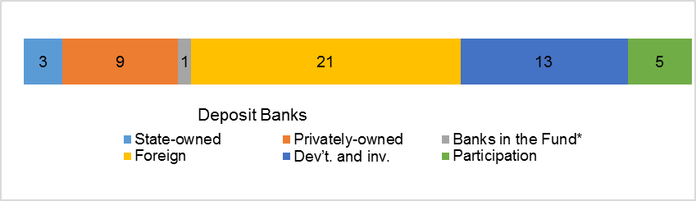*\* Banks under the Deposit Insurance Fund*

Number of Employees

As of end of the 2018, the number of employees in deposit banks and development and investment banks was 192,313.

Number of Employees

|  |  |  |  |
| --- | --- | --- | --- |
|  | **December 2017** | **September 2018** | **December 2018** |
| Deposit banks | 188,266 | 187,919 | 186,918 |
| Dev’t. and inv. banks | 5,238 | 5,424 | 5,395 |
| **Total** | **193,504** | **193,343** | **192,313** |

The number of employees decreased by 1,191 (1 percent), as compared to December 2017 and by 1,030 as compared to previous quarter.

**Number of Employees**

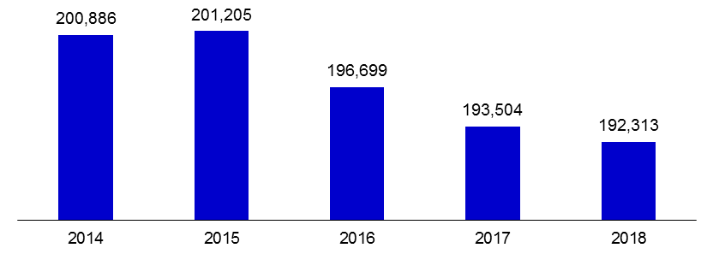

The average number of employees was 5, 498 in deposit banks.

Bank Employees by Gender and Education Level

As of December 2018, 51 percent of the employees were female regarding the distribution of bank employees by gender.

Regarding the education level of bank employees, 78 percent of the employees had undergraduate degrees and 8 percent in postgraduate degrees, as of September 2018. This figure was 13 percent in high-school graduates.

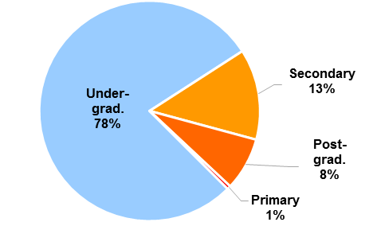Bank Employees by Gender and Education Level

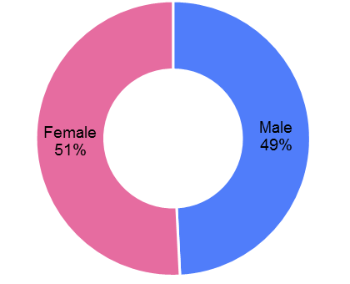

Number of Branches

As of December 2018, the total number of branches in deposit banks and development and investment banks was 10,454.

**Number of Branches\***

|  |  |  |  |
| --- | --- | --- | --- |
|  | **December 2017** | **September 2018** | **December 2018** |
| Deposit banks | 10.500 | 10.452 | 10.400 |
| Dev’t. and inv. banks | 50 | 53 | 54 |
| **Total** | **10.550** | **10.505** | **10.454** |

*\* Branches in foreign countries and Turkish Republic of Northern Cyprus are included.*

The number of branches decreased by 94, as compared to December 2017 and by 51 as compared to previous quarter.

Number of Branches

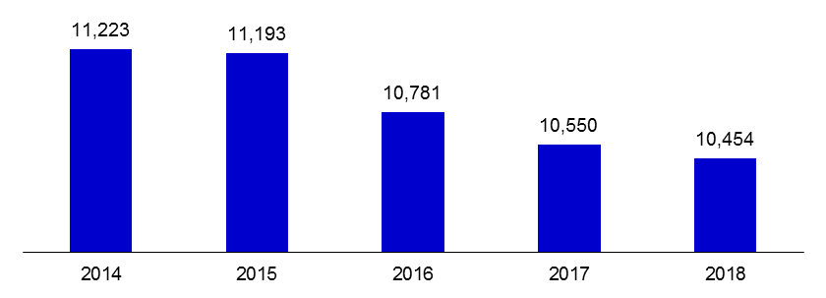

The number of branches per bank was 306 in deposit banks at the end of December 2018.

1. -The deposit banks and development and investment banks are included.