Quarterly Statistics by Banks, Employees and Branches

in Banking System[1]

June 2018

Number of Banks

The number of deposit, development and investment banks was 52 at the end of June 2018 with 34 in deposit banks group and 13 in non-deposit banks group, while there were also 5 participation banks.

**Number of Banks in the System**

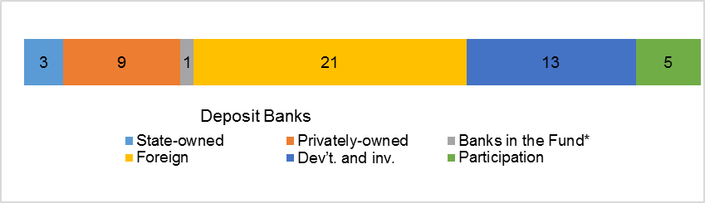*\* Banks under the Deposit Insurance Fund*

Number of Employees

As of June 2018, the number of employees in deposit banks and development and investment banks was 193,815.

Number of Employees

|  |  |  |  |
| --- | --- | --- | --- |
|  | **June 2017** | **March 2018** | **June 2018** |
| Deposit banks | 190,756 | 187,920 | 188,564 |
| Dev’t. and inv. banks | 5,263 | 5,257 | 5,251 |
| **Total** | **196,019** | **193,177** | **193,815** |

The number of employees decreased by 2,204 (1.1 percent), as compared to June2017 and increased by 638 as compared to previous quarter.

**Number of Employees**

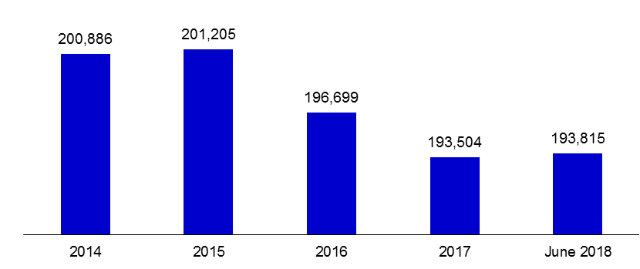

The average number of employees was 5,546 in deposit banks.

Bank Employees by Gender and Education Level

As of June 2018, 51 percent of the employees were female regarding the distribution of bank employees by gender.

Regarding the education level of bank employees, 78 percent of the employees had undergraduate degrees and 8 percent in postgraduate degrees, as of June 2018. This figure was 13 percent in high-school graduates.

Bank Employees by Gender and Education Level

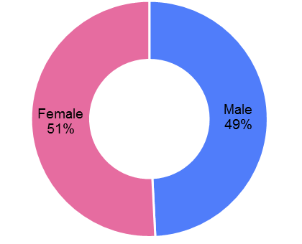

Number of Branches

As of June 2018, the total number of branches in deposit banks and development and investment banks was 10,536.

**Number of Branches\***

|  |  |  |  |
| --- | --- | --- | --- |
|  | **June 2017** | **March 2018** | **June 2018** |
| Deposit banks | 10,679 | 10,460 | 10,483 |
| Dev’t. and inv. banks | 45 | 50 | 53 |
| **Total** | **10,724** | **10,510** | **10,536** |

*\* Branches in foreign countries and Turkish Republic of Northern Cyprus are included.*

This number decreased by 188, as compared to June 2017 and increased by 26 as compared to previous quarter.

Number of Branches

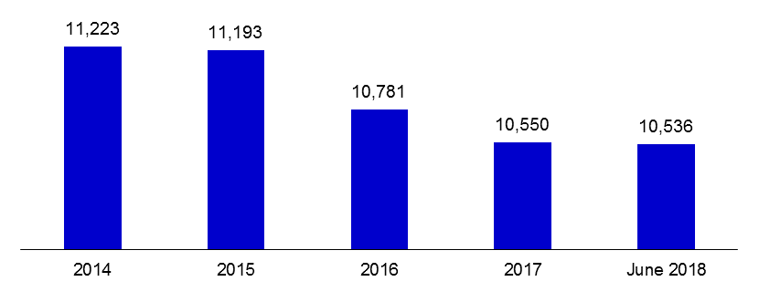

The number of branches per bank was 308 in deposit banks at the end of June 2018.

According to June data, the number of branches and employees decreased compared to the previous year, but they increased compared to the previous quarter.

**Employees per branch**

The average number of employees per branch was 18.4.

Employees per branch

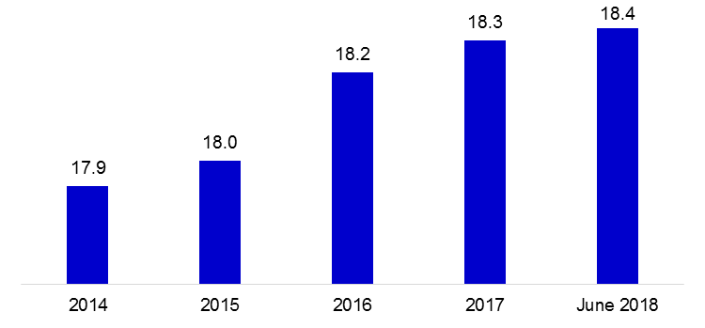

This number was 18 in deposit banks and 99 in development and investment banks as of June 2018.

1. -The deposit banks and development and investment banks are included.