Quarterly Statistics by Banks, Employees and Branches

in Banking System[1]

March 2018

Number of Banks

The number of deposit, development and investment banks was 52 at the end of March 2018 with 34 in deposit banks group and 13 in non-deposit banks group, while there were also 5 participation banks. Bank of China Turkey A.Ş. has taken permission to make banking operations in the "foreign banks founded in Turkey" group, on the 2nd of May, 2016 and started its operations on the 1st of December, 2017.

**Number of Banks in the System**

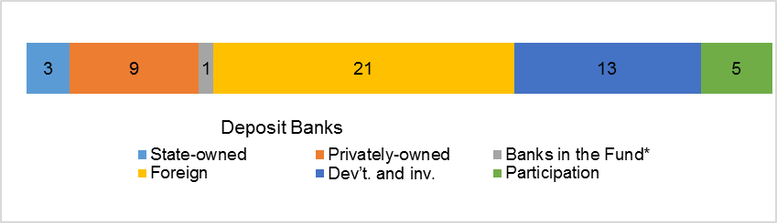*\* Banks under the Deposit Insurance Fund*

Number of Employees

As of March 2018, the number of employees in deposit banks and development and investment banks was 193,177.

Number of Employees

|  |  |  |  |
| --- | --- | --- | --- |
|  | **March 2017** | **December 2017** | **March 2018** |
| Deposit banks | 191,485 | 188,266 | 187,920 |
| Dev’t. and inv. banks | 5,273 | 5,238 | 5,257 |
| **Total** | **196,758** | **193,504** | **193,177** |

The number of employees decreased by 3,851 (1.8 percent), as compared to March 2017 and by 327 as compared to end of the 2017.

**Number of Employees**

The average number of employees was 5,527 in deposit banks.

Bank Employees by Gender and Education Level

As of March 2018, 51 percent of the employees were female regarding the distribution of bank employees by gender.

Regarding the education level of bank employees, 78 percent of the employees had undergraduate degrees and 7 percent in postgraduate degrees, as of March 2018. This figure was 14 percent in high-school graduates.

Bank Employees by Gender and Education Level

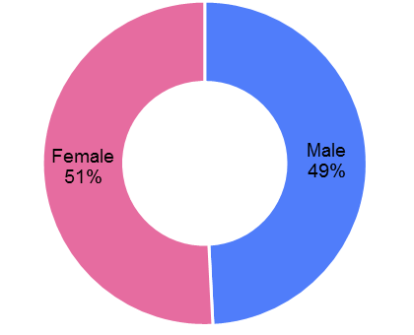

Number of Branches

As of March 2018, the total number of branches in deposit banks and development and investment banks was 10,550.

**Number of Branches\***

|  |  |  |  |
| --- | --- | --- | --- |
|  | **March 2017** | **December 2017** | **March 2018** |
| Deposit banks | 10,712 | 10,500 | 10,460 |
| Dev’t. and inv. banks | 42 | 50 | 50 |
| **Total** | **10,754** | **10,550** | **10,510** |

*\* Branches in foreign countries and Turkish Republic of Northern Cyprus are included.*

This number decreased by 244, as compared to March 2017 and by 40, as compared to December 2017.

Number of Branches

The number of branches per bank was 308 in deposit banks at the end of March 2018.

The rapid growth of non-branch channels and delegation of some services to outsourcing institutions affected the number of employees and branches.

**Employees per branch**

The average number of employees per branch was 18.4. This number was 18 in deposit banks and 105 in development and investment banks as of March 2018.

Employees per branch

1. -The deposit banks and development and investment banks are included.