Banking System in Turkey

“March 2015”

Developments in the Banking Sector

1. General Outlook

The divergence macroeconomic policies in developed countries continued to have an impact on the global economy. While flow of funds to developing countries fluctuating, volatility in currency was effective. With slow growth rate in Turkish economy, depreciation of the TL and higher food prices put pressure on inflation. Although some recovery in profit figures in the banking sector, profitability ratios have remained low. Downside trend in retail loans lost momentum, while corporate loans grew at high rates.

Diverged monetary policy in developed countries caused volatility in developing countries.

In the first quarter of 2015, differences in growth and inflation performance attributed to divergence among advanced economies’ monetary policies. Because of the improvement in labor market and economic recovery in US it was supported that the expectations of Federal Reserve can go to the earlier-than-expected interest rate hikes.

Due to the lack of significant sign of growth in Europe, the European Central Bank started a negative deposit interest rate policy. Also asset purchase program has continued to expanding. Quantitative easing and lower inflation expectations have led to interest rates remain at historic low levels in Europe.

Monetary policy divergence in advanced economies caused volatility in fund flows to developing countries. Due to capital outflows from emerging markets in the first quarter of this year, currencies have depreciated. After Fed's March Monetary Policy Committee meeting minutes the interest rate hike expectations was postponed. Thus flow of funds developing countries has balanced.

Decline in commodity prices, particularly in oil, has become an important factor for global economy. Falling oil price has contributed positively to inflation and current account balance in countries with high external dependence on energy

Real gdp growth stood at 2.9 percent in 2014 in Turkey. Despite weak economic condition in global economy, net exports were the leading contributor to growth across the year. Also, investments remained weak in 2014. Besides, leading growth indicators for the first quarter of 2015 have not showed significant recovery in economic activity. Despite the resurgence seen in industrial production thanks to automotive sector, confidence indices of consumers and firms were declined.

Central Bank lowered the policy interest rates and continued tight liquidity policy.

The Central Bank made a moderate easing in the first quarter of 2015 and continued its tight liquidity policy by keeping the yield curve flat. Despite the fall in oil prices, inflation pressure caused by food prices, has led to a continued tight monetary policy.

Policy interest rate has been reduced 50 basis points in January, 25 basis points in February. Central Bank supported foreign currency liquidity through the export rediscount loans.

Banking sector loans increased in the first quarter of the year.

Retail loans which annual growth rate dropped below 10 percent due to impact of macro-prudential measures have accelerated in the first quarter of 2015. While credit cards have continued to decline on an annual basis, housing loans have been the fastest growing item with 17 percent growth.

In Turkish banking sector falling profitability due to the impact of macro-prudential measures, return on equity increased slightly but remained low in the first quarter of 2015 compared to the same period last year. Banking sector profit increased by 14 percent in the first quarter of the 2015, compared to March 2014. Growth in loans and base effects played important role in the increase in profitability. As of March 2015, average return on equity was 12.2 percent and return on assets was 1.4 percent. All banks had an average return on equity of 11.5 per cent when participation banks are included.

High growth in non-deposit funds in the banking sector continued in the first quarter of the year. Securities issued by banks increased 59.5 percent on an annual basis and amounted to TL 98 billion.

The capital adequacy ratio of the banking sector stood at 15.5 percent.

2. Developments in Balance Sheet Items

Total assets increased by 18.5 percent by March 2015 compared to the same period of 2014. As of March 2015, total assets were TL 2,018 billion (USD 771 billion).

Total assets increased by 19 percent in deposit and development and investment banks, as compared to the March 2014.

By March 2015, compared to the same period of last year, while the share of state owned banks in total assets remained 30 percent, the share of the foreign banks was 50 percent. While the share of state-owned banks in loans increased 1 point, share of private banks decreased by 1 point. On the contrary, state owned banks’ share in total deposit has declined.

Mainly because of the macroprudential measures taken in recent years, including personal loans, slowing credit growth increased slightly in the first quarter of 2015.

Total Assets (USD billion) and Total Assets/Gdp (percent)

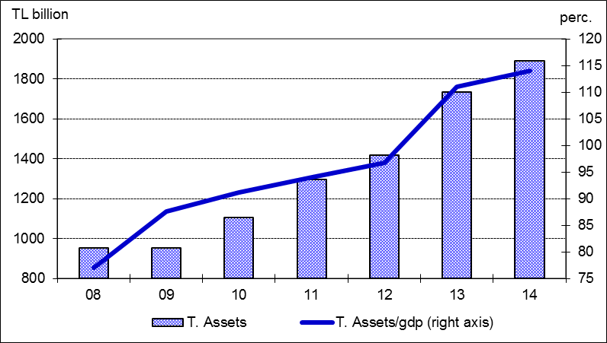

The ratio of loans to total assets realized at 64 percent by increasing 2 percentage points as compared to March 2014. Loans to deposits ratio was 115 percent by increasing 5 points compared to the same period of last year. The same ratio was 103 percent in state-owned banks, 112 percent in private banks and 112 percent in foreign banks as of March 2015.

In the first quarter of 2015 it has not been experienced any deterioration in non-performing loans. The ratio of non-performing loans (NPLs, gross) to loan stock remained at 2.7 percent. Notably, provisions set aside for the non-performing loans were at the level of 74 percent.

Total assets financed 56 percent by deposits. The non-deposit funds to total assets were 26 percent by increasing 2 points compared to March 2014.

The share of TL savings deposits in total deposits fell by 1 point to 34 percent compared to the same month of the previous year. The share of foreign currency deposits accounts increased by 1 percentage points to 37 percent due to the depreciation of TRY.

3. Profitability

Shareholders’ equity was TL 226 billion (USD 86 billion) as of March 2015 with an increase of 17 percent compared to March 2014. Also, the share of equity in total liabilities was 11 percent.

In the first three months of the year, interest income and interest expenses of the sector increased by 15 and 12 percent. Thus, net interest income increased by 18 percent compared to the same period of 2014. By March 2015 the total profit volume of the sector rose by 16 percent compared to the same period of the last year and fell to TL 6.5 billion.

Although, total cumulative profit grew in first quarter of 2015, profitability ratios continued to deteriorate compared to last year on annual basis. While average return on equity was around 12.2 percent, return on assets at the rate of 1.4 percent by March 2015.

By March 2015, the ratio of TL equivalent of FX assets to total assets and the ratio of TL equivalent of FX liabilities to total liabilities became 36 and 44 percent respectively.

Considering maturity, 50 percent of total assets and 77 percent of total liabilities had a maturity of less than 1 year. There was not a considerable change in the average maturity structure of total assets and liabilities compared to December 2014.

4. Selected Issues

As of March 2015, 45 banks were operating in Turkey. The number of branches and employees increased by 181 and 3,146 to 11,233 and 201,217 in the same period, respectively.

The share of first five banks in total assets was 58 percent while their shares in total loans and deposits were at the rate of 56 and 59 percent as of December 2014. Also the share of first ten banks in total assets, deposits and loans were at the rate of 85, 89 and 85 percent respectively.

Deposit banks and development and investment banks are included.
It is the average of the beginning and end of the period
Differences in loan to deposit ratio in sector and banks groups stem from loans of the development and investment banks which are non-depository

