Banking System in Turkey

“September 2014”

Developments in the Banking Sector

Risk perception in global markets continued to be effective in the third quarter of 2014. The Federal Reserve (FED) continued to tapering and, the European Central Bank (ECB) announced new monetary easing policies. In Turkey, the leading indicator pointed to limited recovery in economic activity while inflation continued to rise. The current account deficit was recovered with the support of the declining oil prices in international markets. Banking sector profitability continued to remain low compared to 2013; also, capital adequacy ratio of the sector was stable in the third quarter of 2014

1. General Outlook

With recent recovery in economic activity especially improvement of the labor market, FED continued to reduce asset purchases in the third quarter of 2014. Thus, FED’ asset purchases was ended in October meeting. Also, expected date for hike in interest rates by FED became sooner. However, statements made by the Fed officials and Minutes of the Federal Open Market Committee had contributed steady economic environment.

The economic recovery in the European economy has continued to be weak. In addition, stress tests performed on the European banking sector showed that the 25 banks need additional capital. Due to weak economic outlook, the European Central Bank announced a new quantitative easing program.

One of the most important developments in the third quarter for the global economy has been the decline in oil prices. Limited recovery in global markets and rising oil supply caused a 13% decline in oil prices in the third quarter of the year.

Policy uncertainty in developed countries has led to high risk perception in developing countries. Following the end of the Fed's asset purchases, whether global liquidity can be compensated by the steps taken by the BoJ and ECB seems to be important in the next period.

.

Turkey's gross domestic product (Gdp) increased by 2,1 percent in the second quarter of 2014. Also, inflation continued to remain high. Current account recovery gained momentum with the decline in oil prices and, leading indicators showed limited recovery in the economic activity in the third quarter.

Central Bank of the Republic of Turkey (CBRT) lowered policy rate because the improvement in global capital flows

CBRT decided to cut in the one-week repo rate 50 bps because of the adverse impact of exchange rate on annual inflation was gradually tapering off and the recent improvement in global liquidity conditions.

Weighted average cost of the CBRT funding fell to 8.72 percent from 8.82 percent the third quarter.

The profitability of the banking sector continues to fall

Despite a slight decline, funding costs of the banking sector continued to remain high in the third quarter of 2014. In addition, measures taken on individual loans continued to slow down credit growth. Banking sector continued to use non-deposit funds with foreign borrowing channel.

In the first nine months of the year due to the impact of the maturity mismatch and high funding cost, banking sector profitability declined. Banking sector’ profit decreased by 4 percent in the third quarter of the 2014, compared to the same period of the last year. In parallel with the decline in profit volume, profitability ratios were deteriorated. As of September 2014, average* return on equity was 11.7.

Annual growth rate of the banking sector’ securities gained some momentum and rose to 2.6 percent in the third quarter

Capital adequacy ratio was 16 percent in the third quarter of the year.

2. Developments in Balance Sheet Items

Total assets increased by 17 percent by September 2014 compared to the same period of 2013. As of June 2014, total assets were TL 1,826 billion (USD 801 billion).

Total assets increased by 17 percent in deposit banks; 21 percent in foreign banks and, 26 percent in development and investment banks, as compared to the September 2013.

*: Average of the beginning and end of the period

By September 2014, compared to the same period of last year, while the share of private banks in total assets decreased by 2 point, the share of the foreign banks increased by 1 point. Private Banks share in loans continued to decrease third quarter and dropped to 51 percent.

Due to measures taken by policymaker, primarily including consumer loans, total loan growth rate continued to slowdown. As of September 2014 the growth rate reduced to 20 percent.

Total Assets (USD billion) and Total Assets/Gdp (percent)

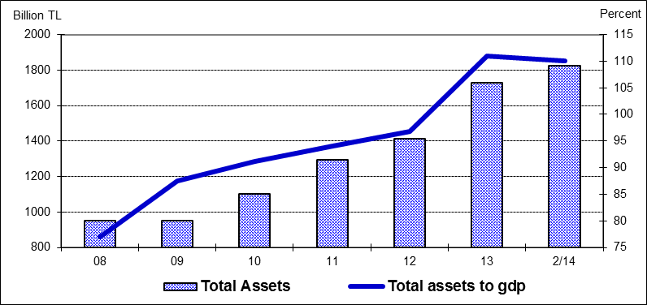

The ratio of loans to total assets realized at 63 percent by increasing 1 percentage points as compared to September 2013. Loans to deposits ratio in deposit banks was 107 percent by increasing 6 percentage points compared to the previous year. The same ratio was 96 percent in state-owned banks, 112, percent in private banks and 109 percent in foreign banks as of September 2014.

The ratio of non-performing loans (NPLs, gross) to loan stock stood at 2.9 percent. Notably, provisions set aside for the non-performing loans were at the level of 76 percent.

Total deposits financed 56 percent of total assets. The non-deposit funds to total assets were 25 percent by September 2014. FX deposits constituted 40 per cent of the total.

Shareholders’ equity was TL 209 billion as of September 2014 with an increase of 16 percent compared to September 2013. Turkish banking sector’ shareholders’ equity raised 4 percent in equity.

3. Profitability

In the second third of the year, as a result of the high interest rates, interest income and interest expenses of the sector increased by 26 and 45 percent. Thus, net interest income increased by 9 percent compared to the same period of 2013.

Profitability ratios continued to deteriorate compared to last year on annual basis. Average return on equity was around 11.7 percent

By September 2014, the ratio of TL equivalent of FX assets to total assets and the ratio of TL equivalent of FX liabilities to total liabilities became 35 and 43 percent respectively.

Considering maturity, 52 percent of total assets and 77 percent of total liabilities had a maturity of less than 1 year. 5 years and 16 percent of total assets had a maturity 5 years and over while their share in total liabilities is 4 percent.

4. Selected Issues

As of September 2014, 46 banks were operating in Turkey. The number of branches and employees increased by 58 and 459 to 11,189 and 199,099 in the same period, respectively.

The share of first five banks in total assets was 58 percent while their shares in total loans and deposits were at the rate of 56 and 59 percent respectively compared to September 2013. Also the share of first ten banks in total assets, deposits and loans were at the rate of 85, 90 and 85 percent respectively.

Deposit banks and development and investment banks are included.

