Banking System in Turkey

“March 2014”

Developments in the Banking Sector

1. General Outlook

While decreasing volatility in the global markets, uncertainty was important in the first quarter of 2014. As a result of the measures taken by the government and macro-prudential regulations in order to limit the impact of global uncertainty, credit growth slowed on an annual basis. Turkish banking sector reacted to the regulations in a short time as an intended. In the first quarter of 2014, commercial loans increased more rapidly than total assets but consumer loans declined.

Although global markets were relatively stable, uncertainty still persists

In the first quarter of 2014, following a relatively positive macroeconomic data released in US, Federal Reserve continued to decrease asset purchases, and emphasized that tight interest rate policy could start sooner than expected.

Despite limited recovery signs in Europe, risk perception on banking sector remained high. In this context, a new quantitative easing program can be revealed by the European Central Bank (ECB) continued to stay on the agenda.

Although the trend was downward, the growth rate in the emerging countries was higher than developed ones. Thus, The International Monetary Fund did not change developed countries’ growth estimates in its last Word Economic Outlook Report; developing countries' forecasts were revised downwards.

In Turkey, in the first quarter of 2014, economic activity was higher than expected, besides industrial production and total loans increased. Inflation rose. On the other hand, tight fiscal policy was maintained and current account deficit narrowed.

The Central Bank continued prudential monetary stance and, increased emphasis on financial stability.

The impacts of monetary tightening, due to global fluctuations risk, high current account deficit, volatile capital flows and rising inflation expectations and prudential banking regulations aimed decelerate the credit growth were showed in a short time. Thus, commercial and consumer loan growth rate diverged.

Policy interest rate was raised to 10 percent from 4.5 percent. in addition to this, prudential banking measures continued to be implemented in the first quarter of the year.

Commercial loans were the main part of balance sheet growth

Depending on higher funding costs, and the tightening of regulations, annual credit growth slowed down significantly. Especially, deceleration was seen on consumer loans. On the other hand, banking sector’ profit margin reduced as a result of the increasing funding cost and rising financial assets price’ with the effect of the maturity structure.

Banking sector’ profit decreased by 19 percent in the first quarter of the 2014, compared to the same period of the last year. In parallel with the decline in profit volume, profitability ratios were deteriorated. As of March 2014, return on equity was 12.5 percent and return on assets was 1.7 percent.

Total assets grew 3.7 percent (TL 65 billion) in the first quarter of the year. And 60 percent of this increase was used in providing new commercial loans. Consumer loans were decreased slightly in the first quarter of the year.

Funds from repo transactions, shareholders’ equity, and FX deposits were main resource items for Turkish banking sector. On the other hand, TL deposits decreased.

Capital adequacy ratio was negatively affected from shrinking profit volume and commercial loans which grew faster than total assets. Consequently capital adequacy ratio decreased by 1.7 points to 15.8 percent in the first quarter of the year.

2. Developments in Balance Sheet Items

Total assets increased by 26 percent by March 2014 compared to the same period of 2013. As of March 2014, total assets were TL 1,701 billion (USD 789 billion).

Total assets increased by 25 percent in deposit banks and 42 percent in development and investment banks, as compared to the March 2013.

Due to measures taken policymaker, primarily including consumer loans, total loan growth rate continued to slowdown. As of March 2014 the growth rate stood at 31 percent.

Total Assets (USD billion) and Total Assets/Gdp (percent)

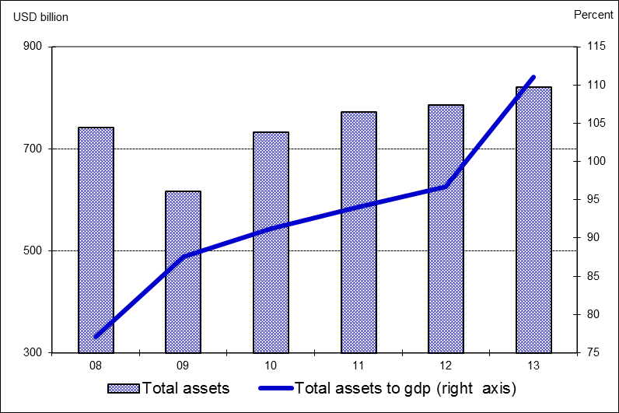

By March 2014, compared to the same period of last year, while the share of state owned banks in total assets increased by 1 point, the share of the foreign banks increased by 2 point. The share of state-owned, foreign and development and investment banks in loans increased in the same period while the share of private banks decreased by 1 point.

The ratio of loans to total assets realized at 62 percent by increasing 2 percentage points as compared to March 2014. Loans to deposits ratio was 110 percent by increasing 8 percentage points compared to the same period of last year. The same ratio was 92 percent in state-owned banks, 110 percent in private banks and 109 percent in foreign banks as of March 2014.

The ratio of non-performing loans (NPLs, gross) to loan stock decreased slightly to 2.7 percent. Notably, provisions set aside for the non-performing loans were at the level of 78 percent.

Total deposits financed 56 percent of total assets by declining 2 percent compared to the same period of last year. The non-deposit funds to total assets were 21 percent by March 2014. Securities issued by banks continued to increase and financed 4 percent of total assets by March 2014.

3. Profitability

Shareholders’ equity was TL 193 billion as of March 2014 with an increase of 8 percent compared to March 2013 mainly due to limited increasing in shareholders’ equity and securities impairment

Compared to March 2013, the capital adequacy ratio declined by 1.7 percent backed by the high growth rate of risk weighted assets and limited rising in shareholders’ equity to 15.8 percent.

In the first three months of the year, as a result of the high interest rates, interest income and interest expenses of the sector increased by 20 and 48 percent. Thus, net interest income decreased by 2 percent compared to the same period of 2013. By March 2014, the total profit volume of the sector decreased by 19 percent compared to the same period of the last year and fell to TL 5.6 billion.

Profitability ratios continued to deteriorate compared to last year on annual basis. While return on equity was around 12.5 percent, return on assets at the rate of 1.7 percent by March 2014.

By March 2014, the ratio of TL equivalent of FX assets to total assets and the ratio of TL equivalent of FX liabilities to total liabilities became 35 and 42 percent respectively.

Considering maturity, 52 percent of total assets and 78 percent of total liabilities had a maturity of less than 1 year. There was not a considerable change in the average maturity structure of total assets and liabilities compared to December 2013.

1.1 percent (TL 11.5 billion) of loans and a 3.3 percent (TL 31.8 billion) of total deposits belong to the risk group of banks. Banks’ net risks arising from their risk groups amount was negative. (TL -20.3 billion).

4. Selected Issues

As of March 2014, 45 banks were operating in Turkey. The number of branches and employees increased by 34 and 862 to 11,055 and 198,327 in the same period, respectively.

The share of first five banks in total assets was 58 percent while their shares in total loans and deposits were at the rate of 56 and 59 percent respectively compared to March 2013. Also the share of first ten banks in total assets, deposits and loans were at the rate of 86, 90 and 84 percent respectively.

Deposit banks and development and investment banks are included.

