Banking System in Turkey
“September 2013”

Developments in the Banking Sector

1. General Outlook

Risk perception is still high.

Despite the recovery signals in the US economy, the ongoing economic weaknesses in European Union and a possible tightening of the global liquidity have kept risk appetite at relatively low levels especially in the emerging markets. The current risk perception also increased the importance of the financial stability in those markets.

Economic activity is expected to gather pace in the second quarter.

The real GDP growth of the Turkish economy is expected to gather pace in the second quarter due to increasing domestic demand and loan growth. However, low savings ratio of the economy and the macro prudential measures are also expected to be the limiting factors of this growth.

The monetary policy measures taken by CBRT in response to global financial risks and the macro prudential measures that are taken in order to limit the retail loan growth started to have negative impact on banking sector since the second half of the year. Amid the increase in the funding costs of the banks due to the current monetary policy, the regulations about risk-weighted assets also put a downward pressure on capital adequacy.

2. Developments in Balance Sheet Items

Total assets increased by 25 percent by September 2013 compared to the same period of 2012. As of September 2013, total assets were TL 1,558 billion (USD 765 billion). The ratio of total assets to gross domestic product is realized 103 percent as of September 2013.

Total assets increased by 25 percent in deposit banks and 29 percent in development and investment banks, as compared to the September 2012.

Total loans increased by 25 percent by September 2013 compared to the same period of 2012. As of September 2013, total assets were TL 1,558 billion (USD 765 billion).

Total Assets (TL billion) and Total Assets/GDP (percent)

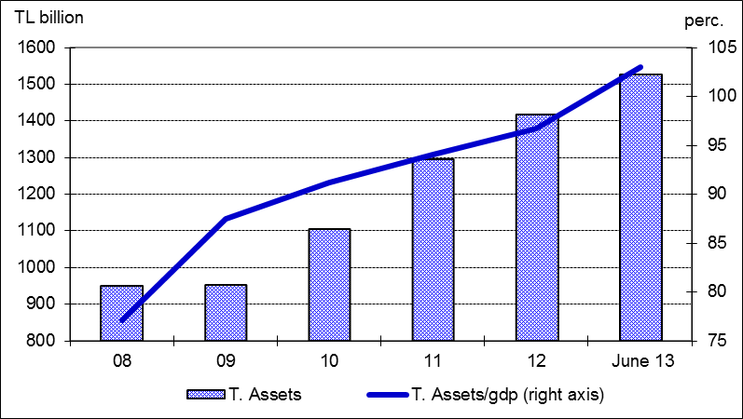

Total loans’ growth rate was realized at 25 percent in the first nine months of 2013 compared to December 2012 and 31 percent year over year. Annual growth rate of loans in the same period of the last year was 14 percent. Corporate loans increased by 32 percent, while consumer loans growth reached at 31 percent by September 2013.

The ratio of loans to total assets realized at 62 percent by increasing about 3 percentage points as compared to September 2012. Loans to deposits ratio was 107 percent by increasing 8 percentage points in the same period. The same ratio was 88 percent in state-owned banks, 107 percent in private banks and 110 percent in foreign banks as of September 2013.

The ratio of non-performing loans (NPLs, gross) to loan stock realized at 2.7 percent, while provisions set aside for the non-performing loans covered 76 percent of NPLs.

Total deposits financed 58 percent of total assets. The non-deposit funds to total assets were 23 percent by September 2013.

3. Profitability

Shareholders’ equity was TL 180 billion as of September 2013 with an increase of 12 percent compared to September 2012 mainly due to rise in profit reserves.

Compared to September 2012, the capital adequacy came down 0.7 percentage points to 15.7 percent by the end of September 2013. The ratio of free shareholders’ equity to total assets also decreased to 9.1 percent from 10.3 percent.

In the first nine months of the year, while the interest income of the sector increased by 2 percent, interest expenses grew at 16 percent. Thus, net interest income increased by 15 percent compared to the same period of 2012. The total profit volume of the sector increased by 16 percent by September 2013 compared to the same period of the last year and reached at TL 19 billion.

On the other hand; amid a downward trend in return on equity, ROE increased by 0.7 percentage points to 14 percent, return on assets is also increased to 1.7 percent from 1.6 percent.

4. Balance Sheet Risks

There was no considerable change in the FX position or maturity risks.

Net foreign exchange position of the banking sector showed a deficit of USD 216 million. Compared to September 2012, the ratio of TL equivalent of FX assets to total assets increased by 3 percent to 33 percent, while the ratio of TL equivalent of FX liabilities to total liabilities increased by 3 percent to 39 percent.

Considering maturity, 52 percent of total assets and 78 percent of total liabilities had a maturity of less than 1 year. There was not a considerable change in the average maturity structure of total assets and liabilities compared to September 2012.

A 1.2 percent (TL 11.5 billion) of loans and a 3.7 percent (TL 33.3 billion) of total deposits belong to the risk group of banks. Banks’ net risks arising from their risk groups amount was negative. (TL -21.8 billion).

5. Selected Issues

The number of branches and employees increased.

As of September 2013, 45 banks are operating in Turkey. The number of branches and employees increased by 7.2 percent and 6.2 percent to 10,834 and 195,823 in the same period, respectively.

The share of first five banks in total assets decreased by 3 percent to 59 percent while their shares in total loans and deposits remain constant at the rate of 57 and 61 percent respectively compared to September 2012. Also the share of first ten banks in total assets decreased by 2 percent to 86 percent, while deposit share remain constant at 91 percent.

Off-balance sheet items increased by 68 percent, especially due to increase in custody and pledged securities.

The growth in the number of credit cards and debit cards along with the volume of transactions continued to increase. Furthermore, regarding the internet banking both the number of customers and the volume of transactions increased.

Deposit banks and development and investment banks are included.

