Banking System in Turkey
“June 2013”

Developments in the Banking Sector

1. General Outlook

Risk perception is still high.

The most important risk factors in economy in the first half of 2013 were the on-going global risks, no signs of improvement in the economy in Euro zone and the expectations of a slowdown in the global growth rate. On the other hand, Fed’s signal of policy change in June 2013, increased finance pressure on the developing countries and the volatility in financial markets.

Increase in economic activity in the first half of the year and accelerated loan growth

The real gdp growth rate accelerated in the first half of the year due to increased domestic demand and public investments, compared to the same period of previous year. In line with the economic resurgence, the annual growth rate of the loan stock increased.

During the same period, the current account deficit grew while the savings rate decreased. The capital inflows slowed down starting from the second quarter of the year. The consumers’ inflation which decreased slightly in the first quarter of the year, started to increase in the second quarter.

Central Bank policies affected banking sector

In the first half of the year, Central Bank decreased the upper bound of the interest corridor and the policy interest rate while increasing the reserve requirement rates. Continuing its prudential approach, Central Bank made limited increases in the the reserve option coefficients.

With the increased volatility in the finance markets following FED’s policy change signal in June, Central Bank’s mixed policy approach became more evident.

2. Developments in Balance Sheet Items

In the first half of the year, growth rate of total assets increased in line with the rising growth pace in loans.

Total assets increased by 19 percent by June 2013 compared to the same period of 2012. As of June 2013, total assets were TL 1,444 billion (USD 750 billion). The ratio of total assets to gross domestic product is realized 98 percent as of June 2013. The ratio is 103 percent, when the participation banks are included.

Total assets increased by 19 percent in deposit banks and 15 percent in development and investment banks, as compared to the June 2012.

Total Assets (USD billion) and Total Assets/Gdp (percent)
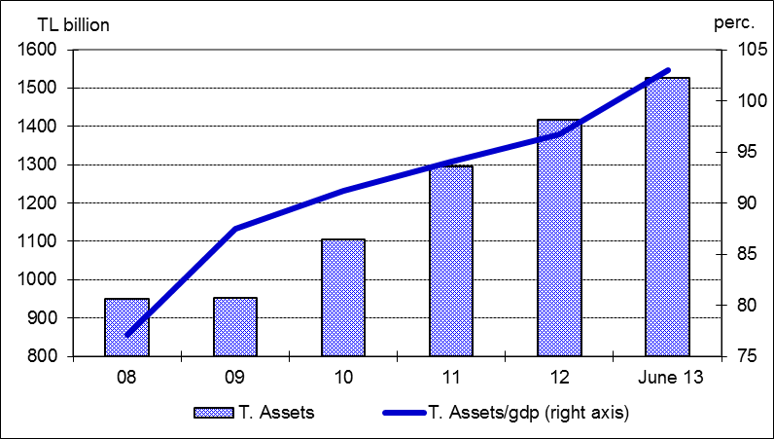

Total loans’ growth rate was realized at 16 percent in the first half of 2013 compared to December 2012 and 24 percent year over year. Annual growth rate of loans in the same period of the last year was 18 percent. Corporate loans increased by 26 percent, while consumer loans growth reached at 27 percent by June 2013.

The ratio of loans to total assets realized at 62 percent by increasing 3 percentage points as compared to June 2012. Loans to deposits ratio was 107 percent by increasing 9 percentage points compared to the same period of last year. The same ratio was 86 percent in state-owned banks, 109 percent in private banks and 113 percent in foreign banks as of June 2013.

The ratio of non-performing loans (NPLs, gross) to loan stock remained nearly same at 2.7 percent. Notably, provisions set aside for the non-performing loans were at the level of 75 percent.

Total deposits financed 58 percent of total assets. The non-deposit funds to total assets were 23 percent by June 2013.

3. Profitability

Shareholders’ equity was TL 176 billion (USD 85 billion) as of June 2013 with an increase of 16 percent compared to June 2012 mainly due to rise in profit reserves.

Compared to June 2012, the capital adequacy ratio declined by 0.2 percentage points to 16.4 percent. The ratio of free shareholders’ equity to total assets increased from 9.6 percent to 9.8 percent in line with the increase in shareholders’ equity.

Due to decline in the interest rates, the interest income of the sector decreased by 3 percent and, interest expenses decline at 22 percent, in the first half of the year. Thus, net interest income increased by 20 percent compared to the same period of 2012. The total profit volume of the sector increased by 19 percent by June 2013 compared to the same period of the last year and reached at TL 13.2 billion.

Return on equity was increased from 7.3 percent to 7.5 percent and return on assets remained same at 0.9 percent in the first half of 2013.

4. Balance Sheet Risks

There was no considerable change in the FX position or maturity risks.

Net foreign exchange position of the banking sector showed a deficit of USD 153 million. Compared to June 2012, the ratio of TL equivalent of FX assets to total assets increased by 3 percent to 33 percent, while the ratio of TL equivalent of FX liabilities to total liabilities increased by 1 percent to 37 percent.

Considering maturity, 51 percent of total assets and 78 percent of total liabilities had a maturity of less than 1 year. There was not a considerable change in the average maturity structure of total assets and liabilities compared to June 2012.

1.1 percent (TL 9.9 billion) of loans and 3.9 percent (TL 32.6 billion) of total deposits belong to the risk group of banks. Banks’ net risks arising from their risk groups amount was negative. (TL -22.7 billion).

5. Selected Issues

The number of branches and employees increased.

As of June 2013, 45 banks operate in Turkey. The number of branches and employees increased respectively by 557 and 8,860 to 10,556 and 192,214 in the same period.

The share of first five banks in total assets decreased by 1 percentage point to 59 percent compared to June 2012, while the shares in loans, and deposits remained the same at 57 percent and 61 percent; respectively. Also the share of first ten banks in assets decreased by 1 percentage point to 86 percent, while the shares in loans, and deposits remained the same at 87 percent, and 91 percent; respectively.

Irrevocable commitments of the off-balance sheet items decreased as a result of the change in their book-keeping, while guaranties and warranties continued to increase.

The growth in the number of credit cards and debit cards along with the volume of transactions continued to increase. Furthermore, regarding the internet banking both the number of customers and the volume of transactions increased.

Deposit banks and development and investment banks are included.

