Banking System in Turkey
“March 2013”

Developments in the Banking Sector

1. General Outlook

Uncertainty on global economy still persists.

The European Central Bank (ECB) kept monetary policy loose and supportive in the second half of 2012 and resolutions were declared on the establishment of a common supervisory mechanism by the formation of a Banking Union among the Euro region countries aimed to eliminate the emergence of a systemic risk; however recent developments in the Southern Cyprus and Italy proved that uncertainty and fragility persisted and led to volatility in risk perception during the first quarter of 2013.

Since liquidity injection to the market by advanced economies still have a limited effect on the real economy, it is forecasted that global economic growth in 2013 not much will likely better than 2012.

Continuation of low cost liquidity to the market by advanced economies and new expansionary policy package declared by Bank of Japan drove interest rates down to the historic low levels and the emerging economies faced with volatile capital inflows.

Monetary and banking sector policies have continued to be prudent. Since the second half of the year 2012, the priority was given to the policies that would sustain the economic growth at a mild level and constrain savings deficit.

The Central Bank (CBRT) has continued to be prudent.

Since the second half of the year either disinflationary impact of domestic demand or improvement in the current account balance, the CBRT increased the liquidity injected to the market and decreased its average funding rate gradually. The CBRT has narrowed down the upper and lower band of interest rate corridor by 150 and 50 basis points, respectively during the first quarter of 2013.

The CBRT has continued to be prudent during the first quarter of 2013 and used reserve requirements and reserve option mechanism effectively. Reserve requirements and reserve option coefficients were both raised for TL and FX liabilities.

Balance sheet growth mainly supported by increase in loan stock.

The ongoing uncertainties in global economy, decelerating economic activity and prudential measures taken by the central bank have impacted the banking sector significantly.

On the other hand, expansionary monetary policy put in force by the CBRT since the second half of the last year and an increase in the capital inflow have led the interest rates and cost of funding further down compared to the same period of the last year. Therefore net interest margin has effected positively and interest rates on loans and deposits started to decrease accordingly.

By March 2013, growth rate of total assets and loans increased by 15 and 19 respectively. Most part of the balance sheet growth stemmed from increase in loan stock. Deposits grew by 13 percent and total loans to deposit rate increased to 102 percent.

In annual basis, profitability ratios remained constant compared to December 2012. While return on equity was around 13.3 percent, return on assets at the rate of 1.7 percent by March 2013.

2. Developments in Balance Sheet Items

Total assets increased by 15.3 percent by March 2013 compared to the same period of 2012. As of March 2013, total assets were TL 1,350 billion (USD 746 billion).

Total assets increased by 15.2 percent in deposit banks and 17.9 percent in development and investment banks, as compared to the March 2012.

Total Assets (USD billion) and Total Assets/Gdp (percent)

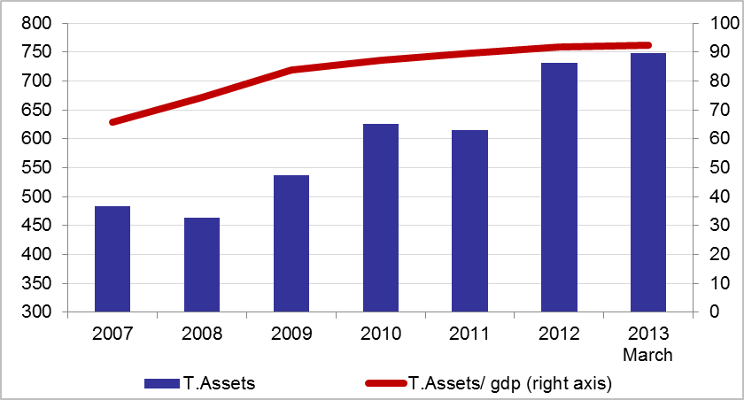

By March 2013, compared to the same period of last year, while the share of state owned banks in total assets decreased by 1 point, the share of the foreign banks increased by 1 point. The share of foreign and private banks in loans increased in the same period while the share of state banks decreased by 1 point.

The ratio of loans to total assets realized at 60 percent by increasing 2 percentage points as compared to December 2012. Loans to deposits ratio was 102 percent by increasing 5 percentage points compared to the same period of last year. The same ratio was 81 percent in state-owned banks, 105 percent in private banks and 106 percent in foreign banks as of March 2013.

The ratio of non-performing loans (NPLs, gross) to loan stock remained nearly same at 2.9 percent. Notably, provisions set aside for the non-performing loans were at the level of 75 percent.

Total deposits financed 58 percent of total assets by declining 2 percent compared to the same period of last year. The non-deposit funds to total assets were 21 percent by March 2013. Securities issued by banks continued to increase and financed 3 percent of total assets by March 2013.

3. Profitability

Shareholders’ equity was TL 179 billion as of March 2013 with an increase of 22 percent compared to March 2012 mainly due to rise in profit reserves.

Compared to March 2012, the capital adequacy ratio increased by 1 percent backed by strong rise in shareholders’ equity to 17.6 percent.

In the first three months of the year, while the interest income of the sector remained the same, interest expenses decreased by 21 percent. Thus, net interest income increased by 26 percent compared to the same period of 2012. By March 2013, the total profit volume of the sector increased by 19 percent compared to the same period of the last year and reached at TL 6.8 billion.

In annual basis, profitability ratios remain constant compared to last year. While return on equity is around 13.3 percent, return on assets at the rate of 1.7 percent by March 2013.

By March 2013, the ratio of TL equivalent of FX assets to total assets and the ratio of TL equivalent of FX liabilities to total liabilities became 31 and 36 percent respectively.

Considering maturity, 52 percent of total assets and 77 percent of total liabilities had a maturity of less than 1 year. There was not a considerable change in the average maturity structure of total assets and liabilities compared to December 2012.

1.1 percent (TL 8.9 billion) of loans and a 3.4 percent (TL 26.6 billion) of total deposits belong to the risk group of banks. Banks’ net risks arising from their risk groups amount was negative. (TL -17.7 billion).

4. Selected Issues

The number of branches and employees increased.

As of March 2013, 45 banks are operating in Turkey. The number of branches and employees increased by 147 and 2,650 to 10,381 and 188,748 in the same period, respectively.

The share of first five banks in total assets was 59 percent while their shares in total loans and deposits remain constant at the rate of 57 and 61 percent respectively compared to March 2012. Also the share of first ten banks in total assets, deposits and loans were at the rate of 86, 91 and 86 percent respectively.

Deposit banks and development and investment banks are included.

