Banking System in Turkey
“June 2012”

Developments in the Banking Sector

1. General Outlook

Risk perception is still high.

Concerns over global growth and financial stability along with the ongoing uncertainty regarding the Euro area has remained the major risk for the global economy in the first half of 2012.

Decline in economic activity was more evident in the first half of 2012.

Monetary and banking sector policies have continued to be prudent in the first half of the year 2012. After a high growth rate and a rapid increase in loans in 2011, in the second half of 2011, priority was given to the policies that would decelerate the economic growth and constrain current account deficit. With the declining economic activity, the lower oil prices also helped efforts to limit current account deficit and inflation.

Banking sector performance has been determined notably by the measures taken by the Central Bank of Turkey.

The growth rate of the total assets has started to decline on the back of monetary and banking policies since the last quarter of 2011 and slowdown trend in the growth rate has continued in the first half of 2012.

Regulations on the allowance of the reserve requirements for TL liabilities to be held as FX and gold has enabled the Turkish banking system to meet its liquidity needs at a relatively lower cost.

2. Developments in Balance Sheet Items

In the first half of the year, growth rate of total assets decreased in line with the slowdown in loans.

Total assets increased by 10 percent in the first half of the year compared to the same period of 2011. As of June 2012, total assets were TL 1.212 billion (USD 671 billion). The ratio of total assets to gross domestic product is estimated 89 percent as of June 2012.

Total assets increased by 9 percent in deposit banks and 48 percent in development and investment banks, as compared to the June 2011.

Total Assets (USD billion) and Total Assets/Gdp (percent)

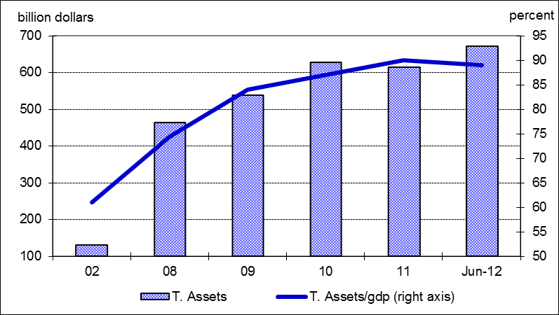

Given the constant currency basket (0.5 euro + 0.5 USD) by the end of 2010, total loans’ growth rate was realized at 10 percent in the first half of 2012 compared to December 2011 and 18 percent year over year. Annual growth rate of loans in the same period of the last year was 31 percent at fixed FX rates of 2010 December. Corporate loans increased by 20 percent, while consumer loans growth reached at 18 percent by June 2012.

The ratio of loans to total assets realized at 59 percent by increasing 4 percentage points as compared to June 2011. Loans to deposits ratio was 98 percent by increasing 7 percentage points in the same period. The same ratio was 77 percent in state-owned banks, 101 percent in private banks and 106 percent in foreign banks as of June 2012.

The ratio of non-performing loans (NPLs, gross) to loan stock remained the same at 2.7 percent by the end of June 2012. Notably, provisions were set aside for 80 percent of the non-performing loans.

Total deposits financed 60 percent of total assets. The non-deposit funds to total assets was 21 percent by June 2012.

3. Profitability

Shareholders’ equity was TL 153 billion (USD 84.5 billion) as of June 2012 with an increase of 15 percent compared to June 2011 mainly due to rise in profit reserves.

Compared to June 2011, the capital adequacy ratio declined by 0.7 percentage points to 16.6 percent in the first half of 2012. The ratio of free shareholders’ equity to total assets increased from 9.2 percent to 9.6 percent in line with the increase in shareholders’ equity.

In the first half of the year, while the interest income of the sector increased by 37 percent, interest expenses grew at 39 percent. Thus, net interest income increased by 34 percent compared to the same period of 2011. The total profit volume of the sector increased by 11 percent by June 2012 compared to the same period of the last year and reached at TL 11.09 billion (USD 6.15 billion).

Return on equity was decreased from 14.5 percent in June 2011 to 13.2 percent on annual basis and return on assets decreased from 1.8 percent to 1.7 percent in the same period.

4. Balance Sheet Risks

There was no considerable change in the FX position or maturity risks.

Net foreign exchange position of the banking sector showed a deficit of USD 153 million. Compared to June 2011, the ratio of TL equivalent of FX assets to total assets increased by 2 percent to 29 percent, while the ratio of TL equivalent of FX liabilities to total liabilities increased by 4 percent to 36 percent.

Considering maturity, 48 percent of total assets and 79 percent of total liabilities had a maturity of less than 1 year. There was not a considerable change in the average maturity structure of total assets and liabilities compared to June 2011.

A 1.3 percent (TL 9.3 billion) of loans and a 4 percent (TL 26.7 billion) of total deposits belong to the risk group of banks. Banks’ net risks arising from their risk groups amount was negative. (TL -17.4 billion).

5. Selected Issues

The number of branches and employees increased.

As of June 2012, 44 banks are operating in Turkey. The number of branches and employees increased by 267 and 1,766 to 9,979 and 183,354 in the same period, respectively. The share of first five banks in total assets, deposits and loans decreased by 2, 4 and 1 percent to 60, 61 and 57 percent respectively compared to June 2011. Also the share of first ten banks in loans decreased by 2 percentage points to 86 percent, while the shares in assets, and deposits remained the same at 87 percent, and 91 percent; respectively.

Off-balance sheet items continued to grow especially due to the increase in “custody and pledged securities” item.

The growth in the number of credit cards and debit cards along with the volume of transactions continued to increase. Furthermore, regarding the internet banking both the number of customers and the volume of transactions increased.

Deposit banks and development and investment banks are included.
Deposits collected from banks are included.

