Banking System in Turkey
“March 2012”

Developments in the Banking Sector

1. General Outlook

1.1. Economic Review

Economic growth has slowed down in the first quarter of 2012.

Turkish economy has slowed down in the first quarter of 2012 on the back of continuing debt crises and uncertainties in some European Union countries along with the declining domestic demand.

Risk perception is still high.

The on-going debt problems that have not been solved yet and political changes in some European countries led to increase in the risk perception. On the Turkey’s side, high current account deficit, despite of its declining trend in parallel with the economic slowdown, and deterioration in the inflation expectations due to recent inflation data significantly above the Central Bank estimation were the factors augmenting the risk perception.

Profits increased and decline in the profitability stopped.

Compared to the same period of the last year, net profit surged in line with the increasing transaction volume. Despite the positive effect of increase in the banking services income, hike in the provisions and personnel expenses led to decrease in the net noninterest income. In the first quarter of 2012, net current profit surged by 11 percent compared to the first quarter of 2011 and decline in the return on equity ratio stopped.

1.2. Developments in Balance Sheet Items

In the first three months of the year, total assets increased in line with the hike in loans.

Total assets increased by 17 percent in the first three months of the year compared to the same period of 2011. As of March 2012, total assets were TL 1.171 billion (USD 660 billion). The ratio of total assets to gross domestic product is estimated 87 percent as of March 2012.

Total assets increased by 16 percent in deposit banks and 37 percent in development and investment banks, as compared to the March 2011.

In the same period, the shares of private banks in total loans increased by 1 percentage point, while the share of foreign banks decreased by 1 percentage points.

Total Assets (TL Million) and Total Assets Growth Rate (Percent)

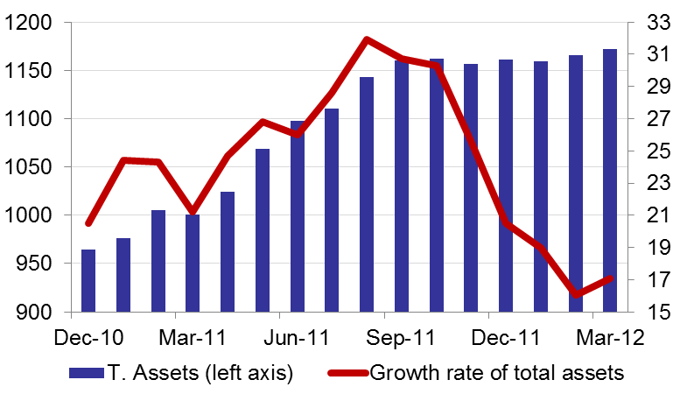

The ratio of loans to total assets realized at 58 percent by increasing 3 percentage points as compared to March 2011. Loans to deposits ratio was 97 percent by increasing 10 percentage points in the same period. The same ratio was 81 percent in state-owned banks, 104 percent in private banks and 108 percent in foreign banks as of March 2012.

As of March 2012, retail loans grew by 24 percent annually. The rapid growth in retail loans was mainly due to the growth in mortgage and other (general purpose) retail loans. The share of mortgage and other retail loans in total loans is 10 and 13 percent, respectively.

The share of loans under follow-up in total loans is 2.8 percent. The loans under follow-up increased nominally in line with the slowdown in economic activity. The coverage ratio of loan loss provisions to nonperforming loans decreased slightly and realized as 80 percent.

The share of non-deposit funds in liabilities increased.

As of March 2012 the share of non-deposits funds in total liabilities increased compared to the same period of previous year. This increase resulted from the growth in funds provided from bonds issued, repo aggrements and funds from abroad.

Shareholders’ equity was TL 147 billion (USD 83 billion) as of March 2012 with an increase of 13 percent compared to March 2011. This growth was supported mainly by the increase in paid-in capital and extraordinary reserves.

Compared to March 2011, the capital adequacy ratio declined by 1.4 percentage points to 16.7 percent in the first quarter of 2012. The growth in the loan stock has been effective in the deterioration in the capital adequacy ratio.

1.3. Profitability

Profitability decreased on yearly basis.

Increase in the portion of loans as part of yielding assets and soar in the non -deposit funds in the funding of the assets decreased the difference between loans interest income and deposit interest expenditure. While interest income increased by 39 percent compared to the same period of the previous year; interest expenditure surged by 50 percent and net interest income increased by 28 percent.

In the first three months of the year, interest income was TL 26.3 billion and the interest expenses were TL 14.6 billion. Net interest income increased by 28 percent to TL 11.7 billion compared to the same period of 2011.

Compared to the same period of previous year, profits increased by 8 percent to TL 5.7 billion.

Return on equity was decreased from 15.7 percent in March 2011 to 14.1 percent on annual basis and return on assets decreased from 2.1 percent to 1.7 percent in the same period. Thus, annual profitability continued to deteriorate.

1.4. Balance Sheet Risks

There was no considerable change in the FX position or maturity risks.

Net foreign exchange position of the banking sector showed a surplus of USD 443 million. Compared to March 2011, the ratio of TL equivalent of FX assets to total assets increased by 3 percentage points to 29 percent and the ratio of TL equivalent of FX liabilities to total liabilities increased by 4 percent points to 35 percent.

Considering maturity, 45 percent of total assets and 79 percent of total liabilities had a maturity of less than 1 year. There was not a considerable change in the average maturity structure of total assets and liabilities compared to the same period of last year.

A 1.4 percent (TL 9.5 billion) of loans and a 3.7 percent (TL 25.6 billion) of total deposits belong to the risk group of banks. Banks’ net risks arising from their risk groups amount was negative. (TL -16.1 billion).

1.5. Selected Issues

While the number of branches increased, the number employees remained constant.

As of March 2012, the number of banks operating in Turkey is 44. The number of branches increased by 52 to 9,886 and the number of employees decreased by 3 to 181,415 compared to the same period of the last year.

The share of first five banks in total assets remained constant while the shares in deposits and loans increased by 1 percent to 61 and 58 percent respectively compared to December 2011. Also the share of first ten banks in loans, assets and deposits remained constant at 87 percent, 87 percent and 91 percent; respectively.

Off-balance sheet items continued to grow especially due to the increase in derivatives for trading transactions item and revocable commitments item.

The number of debit cards and credit cards along with the volume of transactions continued to increase. As for the transactions carried out through internet and mobile banking, both the number of customers and the volume of transactions continued to increase.

Deposit banks and development and investment banks are included.

